|  |  |  |  |  |
| --- | --- | --- | --- | --- |
|  | | |  |  |
| Technical Design Specification | | | | |
| Compliance Link Integration | | | | |
| Regional Services | | | | |
|  | | | | |
|  | | | | |
| **Version:1** | | **Issue Date:** | | |
| **Author:Pablo Garcia** | | **Document Class: Draft** | | |
|  |  | | | |

Approvals:

| Name | Role | Signature | Date |
| --- | --- | --- | --- |
|  |  |  |  |
|  |  |  |  |
|  |  |  |  |
|  |  |  |  |

Distribution:

| Name | Role |
| --- | --- |
|  |  |
|  |  |
|  |  |
|  |  |

Document History:

The following versions of the document have been produced:

|  |  |  |  |  |
| --- | --- | --- | --- | --- |
| Vers. | Status | Issue Date | Author | Reason for Issue |
| 0.1 |  |  |  |  |
|  |  |  |  |  |
|  |  |  |  |  |

Project Specific Documentation

| Ref | Document Name | Author | Version | Issue Date |
| --- | --- | --- | --- | --- |
| 1 |  |  |  |  |
|  |  |  |  |  |
|  |  |  |  |  |

**a**

Contents

2 Introduction 7

2.1 Background 7

2.2 Business Need and Opportunity (Executive Summary) 7

2.3 Requirements Summary 7

2.3.1 Scope 7

2.3.2 Out of Scope 8

2.4 Objectives 8

2.5 Assumptions, Dependencies and Constraints 8

2.6 Definitions and Acronyms (Glossary) 9

2.7 Reference Documentation 9

3 Design Approach 9

3.1 Project Scope 9

3.2 Design Principles (Systems Functions Data) 9

3.3 Design Constraints 11

3.4 Assumptions 11

4 Implementation- Chubb IO Services (Microservice component) 11

4.1 Model – Online Screening – (Sync & Asyn process) 11

4.1.1 Sequence Diagram – Online Screening (Sync call) 14

4.1.2 Sequence Diagram – Online Screening (ASync call) 14

4.1.3 Class Diagram 15

4.1.4 Input / Request data 15

4.1.5 Master Data 15

4.1.6 Compliance link – Global Screening 19

4.1.7 Compliance link – Sanction list - Region 32

4.1.8 Business Rule for Online Screening 34

4.2 Model Batch Process 36

4.2.1 Logical flow 36

4.2.2 Sequence diagram 37

4.2.3 SFTP Location 38

4.2.4 Input File format (Source System) 38

4.2.5 File format (Compliance link Global /Region) 38

4.2.6 Output file format (to source system) 41

4.3 Model Clearance Process 42

4.3.1 Sequence diagram (Global) 42

4.3.2 Sequence diagram (Region) 42

4.4 Utility features 43

4.4.1 Audit 43

4.4.2 Error / Exception Log 43

5 Implementation - Case Manager: 44

5.1 Sequence Diagrams: 45

**5.2** **Error Handling and Logging Design:** 47

5.3 Design Patterns (System Interaction Flowchart) 47

5.3.1 Figure 1: Example implementation of Model View Presenter pattern for ASP.Net 47

5.4 Policy Document Generation 47

5.5 Interface to Back Office System 47

5.6 Template Management 47

5.7 Rendering Service 47

5.8 Document Storage and Retrieval 47

5.8.1 Http Servlet 47

5.8.2 StoreDoc 47

5.8.3 RetrieveDoc 48

5.8.4 Messages 48

5.8.5 Message 1 48

5.8.6 Message 2 48

5.8.7 Services 48

5.8.8 Service 1 48

5.8.9 Service 2 48

5.9 New System Interfaces 48

5.9.1 Operations Inputs 49

5.10 Changed/Deleted System Interfaces 58

6 Physical Deployment 58

6.1 Policy Document Generation 58

6.1.1 Referencing 58

6.1.2 Deployment Details 58

6.1.3 Clustering 58

6.2 Lookup Services 58

6.3 Process Coordination 58

6.4 Interface Back Office Systems 58

6.5 Template Management 58

6.6 Rendering Service 59

6.7 Document Storage and Retrieval 59

6.8 Security 59

7 Non-Functional Design Considerations 59

7.1 Performance 59

7.1.1 Memory 59

7.1.2 I/O 59

7.1.3 Cacheing 59

7.1.4 Stored Procedures 59

7.1.5 Use 59

7.1.6 Instantiation 59

7.1.7 Transaction Throughput and Response Times 59

7.2 Resilience 59

7.3 Reliability 59

7.4 Scalability 59

7.5 Data Backup 59

7.6 System Healthcheck Considerations 59

8 Database Design 60

8.1 Data Dictionary 60

8.2 Managed Document 60

8.2.1 Doc Version 60

8.2.2 Nested Version 60

8.2.3 Data Content 60

8.2.4 Format 61

8.3 Entity Relationship Diagram 62

8.4 Database Design Considerations 63

8.4.1 Database Files – New/Changed/Deleted 63

1.1.1 Impacted Files 63

Impacted File Details 63

9 User Interface 63

9.1 Screen Mock-ups 63

9.2 7.2 Impacted User Interface/Screens 74

9.3 7.3 User Interface/Screen Details 74

9.4 7.4 Plug-ins and Controls 75

9.5 7.5 3rd Party Controls 75

10 8. Reports 75

10.1 8.1 Impacted Reports 75

8.1.1 Impacted Report Details 75

11 9. Taxonomy 75

12 Security 75

12.1 Authentication 75

12.1.1 User 75

12.1.2 Databases 75

12.1.3 Other Applications 75

12.1.4 Password Rules 75

12.1.5 Format 75

12.1.6 Expiry 75

12.1.7 Resets 75

12.2 Authorization 75

10.2.1 Access Levels 75

12.2.1 Groups 76

12.3 Security Components 76

12.3.1 Active Directory 76

12.3.2 Authentication Table 76

13 Testing Considerations 76

14 Open Issues 77

15 Appendices 77

# Introduction

## Background

This projects cover the implementation of the screening data (in real time and batch) in all of the LATAM systems and workflows using the integration of the Global compliance link service (Global sanction lists) and the regional sanction list (Local regulatory compliance list per each country). This is the implementation of screening service/component to check global and local sanction list in the claims/payment and underwriting processes.

To be aligned with the Global Chubb and Regional regulations.

## Business Need and Opportunity (Executive Summary)

Compliance Link project is to provide a solution to replace FAC Bridge Services and getting a unique point of comunication between Front end systems and underwriting processes. Some objetives are

* Ensure compliance with local and global screening regulations
* Provide for efficiency in terms of resources and process as well as reliability on the results.
* Standardize screening, for all applications used in LATAM
* Centralize in the region all the production support and BAU necessities attachable to screening purposes, this will be in charge of Shared Services team

Also the benefits are

* Avoid local or customized developments by application, based on workflows, that are not aligned with global and local regulation
* Standardization of Screening of global and local lists in all binding and claims processes
* Avoid hiring local vendors to cover the needs of the screening local processes
* Reduce compliance manual process, such as AML, scorings, screenings, with the aim of avoiding human errors and non-compliance with defined procedures

## Requirements Summary

|  |
| --- |
| **User History** |
| * 1. HUS_01_00_01_REST/API synchronous service - User story – 01_00_01 |
| * 1. HUS_01_00_02_ Sanction List Regional Service - User story – 01_00_02 |
| * 1. HUS_01_00_03_ Case Manager - User story – 01_00_03 |
| * 1. HUS_01_00_04_ Screening Batch - User story – 01_00_04 |
| * 1. TBC |

### Scope

* Integrator Service
  + Data Validations
* Data Mapping
* Communicate with orchestrator
* Error Responses
* Orchestrator
  + Manage Request
  + Create threads for simultaneously calls to CL and RL
  + Execute Request
  + Receive Responses
  + Hit Validations
  + Uses Queues for failure on the services responses
* Handler for Async Calls
* Clearance Regional Service
* Notifications
* Batch Regional Process
* Case Manager
  + Case Manager Front End
  + Case Manager Business layer
  + Case Manager Data Access layer

### Out of Scope

* Changes to frontend systems not associated to project requirements
* Changes to interfaces not associated to project requirements
* Any other change or new component not included on requirements
* Changes in Compliance Link
* Changes in the existing components

## Objectives

The project scope include the Case Manager (User Interface), which allows the clearence users, throught the clearence process and the proper notification to the correct front end system.

Also the Case Manager will provide a IT access for specific user in order to see the complete trace for te selected transaction.

Case Manager will provide a scalation flow, where an manager user can selected and delegate transaction to an specific user.

Middleware using ChubbIO Frameworks is a set of services and components this will replace of Biztalk server. This functionality covers from the screening online process and batch process.

The new system environment (Middleware) will include a Integrator service as entry point, providing a single contract – interface – common for all front end systems.

Middleware will be on charge of the orchestration, dealing with Synch/Async process and calls, also allow save in the database the complete trace for every transaction. Besides also will handle all the notificacions to the front end systems.

## Assumptions, Dependencies and Constraints

* The Chubb IO framework is in place for the server used in LATAM
* The Sanction list Serve is on charge of the validations for the validations against specific list per country, and return the response.
* The Sanction list service (Regional/Global) will be available 24/7, the existing services.
* E-Mail Server needs to be available for development environment.
* Dependency - Chubb will share the Database Diagram of existing Regional Database.
* Dependency - Chubb team will approve functional, technical documentation, before to start development activities.
* Dependency - Chubb will share testing data.
* Dependency - Chubb needs to grant the access to all the environments, including repository server (Dev, QA, UAT).
* Dependency/Assumptions – Chubb will to provide the VDI for development activities.
* Dependency – Chubb will share Authentication/certifications to access the services.
* Dependency – Chubb will share User Interface mockup for Case Manager.
* The Middleware it’s going to be developed use JAVA technologies (Apache Camel, springboot).
* Case Manager it’s going to be developed use .NET Framework.

## Definitions and Acronyms (Glossary)

## Reference Documentation

# Design Approach

## Project Scope

* Integrator Service
  + Data Validations
* Data Mapping
* Communicate with orchestrator
* Error Responses
* Orchestrator
  + Manage Request
  + Create threads for simultaneously calls to CL and RL
  + Execute Request
  + Receive Responses
  + Hit Validations
  + Uses Queues for failure on the services responses
* Handler for Async Calls
* Clearance Service
* Notifications
* Batch Process
* Case Manager
  + Case Manager Front End
  + Case Manager Business layer
  + Case Manager Data Access layer

## Design Principles (Systems Functions Data)

**Logging and Audit Principles**

1. Audit information must be stored in database table(s).
2. Audit information may be used for non-repudiation activities.
3. Logging information must be provided to indicate system issues for system supportability. Logging information may be stored in files or to persistent storage mechanisms specific to individual components e.g. Search Server.
4. Logging information will be used for defect and performance analysis and will not be used for non-repudiation purposes.
5. Logging levels should be configurable – typically detailed when developing and debug and only critical / alerts for production.

**Interoperability Principles**

1. All access to databases must be made through a data access layer.

**Infrastructure Standards**

1. Case Manager and associate process: Needs a Server with IIS, Net Core 3.0 and framework 4.7 (dev, qa, uat).

More information can be reach out in   
<https://docs.microsoft.com/en-us/aspnet/core/host-and-deploy/iis/?view=aspnetcore-3.0>

1. The front end will be developed using ReactJS. This framework will allow the interfaces to be
   1. Nicer,
   2. faster: The core of the framework offers a virtual DOM program and server-side rendering, which makes complex apps run extremely fast,
   3. more maintainable and flexible: due to its modular structure. This flexibility saves huge amount of time and cost to business.

Case Manager solution

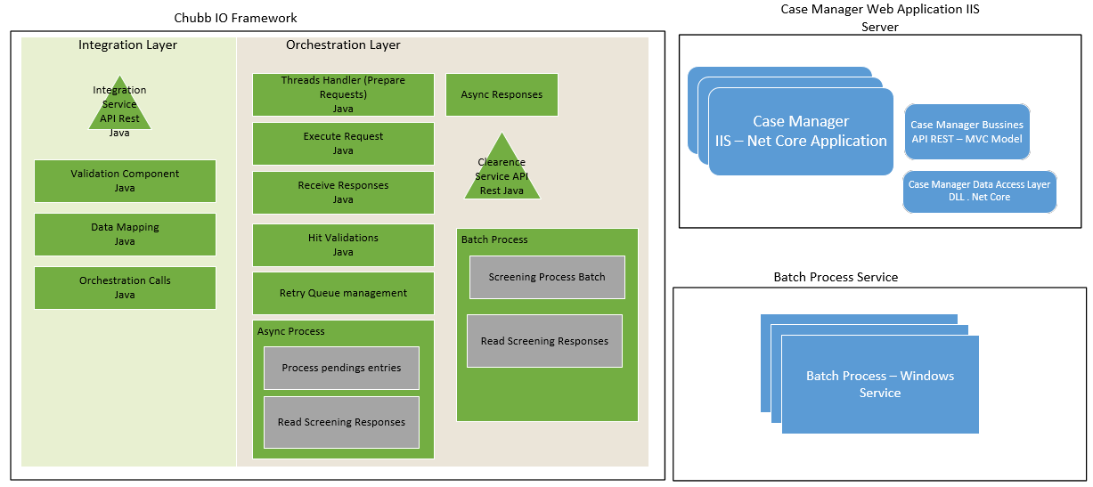 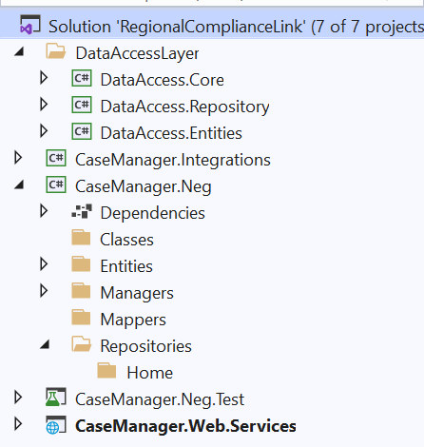

The web services (API Rest), use swagger for documentatios will allow the user make calls to the API.

Example:

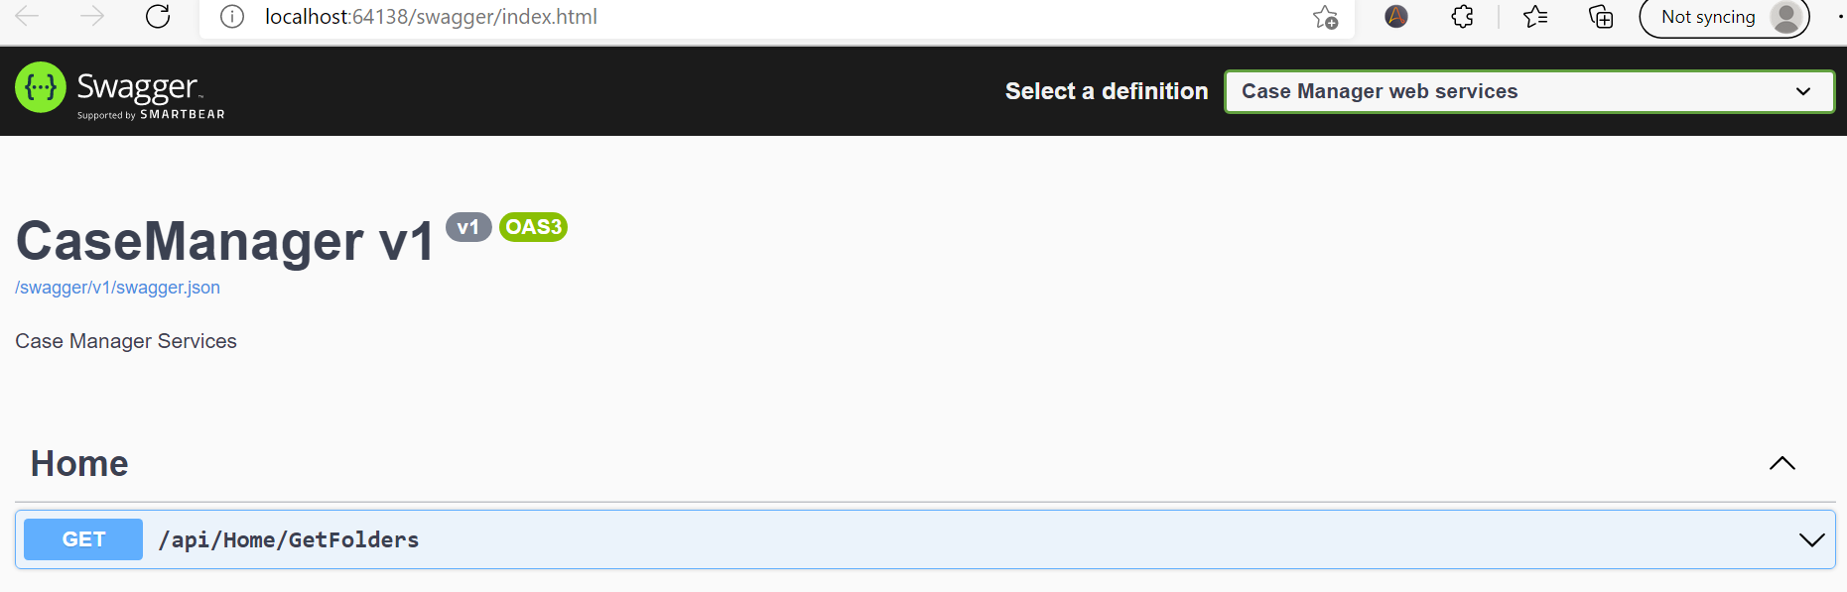

Case Manager – Server specifications

|  |  |  |  |  |  |  |  |  |  |
| --- | --- | --- | --- | --- | --- | --- | --- | --- | --- |
|  |  |  |  | DEV UAT | | Pre Prod | | PROD | |
| **#** | **Servicio** | **Tecnologia** | **SO** | **#vCPU** | **#RAM (GB)** | **#vCPU** | **#RAM (GB)** | **#vCPU** | **#RAM (GB)** |
| 1 | Case Manager (*) | NET Core 5.0 | WinServer X64 | 2 | 4 | 4 | 8 | 8 | 16 |

(*) This hardware requirements are not taking into account the data base server, this will operating in other server.

1. Chubb IO:

## Design Constraints

**There is no need to reply with a combinated response. That’s means Global Compliance Link will sent his owns notifications, in the other hand, Regional Compliance Link will sent his owns notifications independent each other.**

**Batch process not include transformations, mappings for handle for Global Compliance Link.**

**There is an example of how that Orchestrator have to invoque both services, based on the input request type we have to form the request, this are the three combinations possibles**

|  |  |  |  |
| --- | --- | --- | --- |
| Resources for Global Service | |  | Resource for Regional Service |
| 1 | Policy | and | ValitePerson |
| 2 | Claim | and | ValidatePerson |
| 3 | Claim Payment | and | ValidatePerson |

## Assumptions

# Implementation- Chubb IO Services (Microservice component)

Chubb has a vision of modernizing by taking a standardized reusable low-cost platform centric approach. Chubb.IO has adopted this vision for the Integration layer by leveraging open-source technologies for the platform.

Compliance link application will follow the Integration layer - Chubb IO, which is recommended approach by Chubb Enterprise Architecture strategy.

Following integration service will be developed in Chubb IO.

* CLSync Service
* CLAsyn Service
* Clearance Service
* CLBatchService

## Model – Online Screening – (Sync & Asyn process)

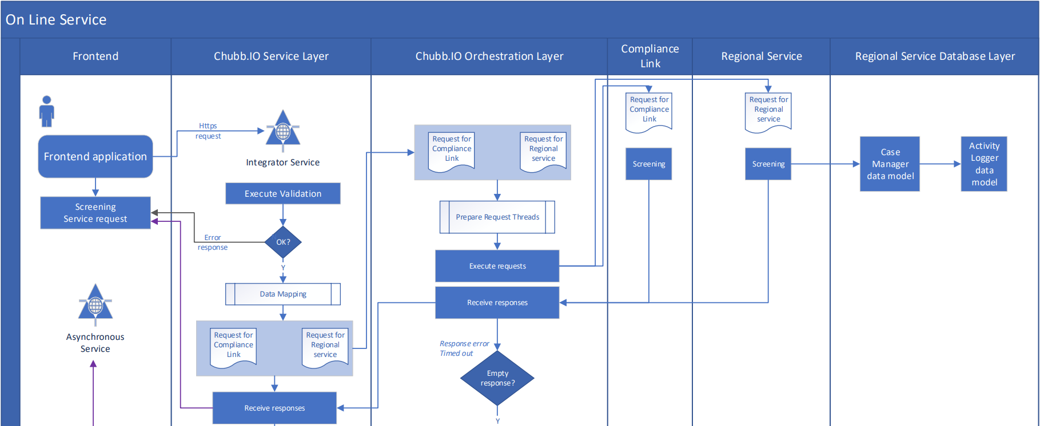

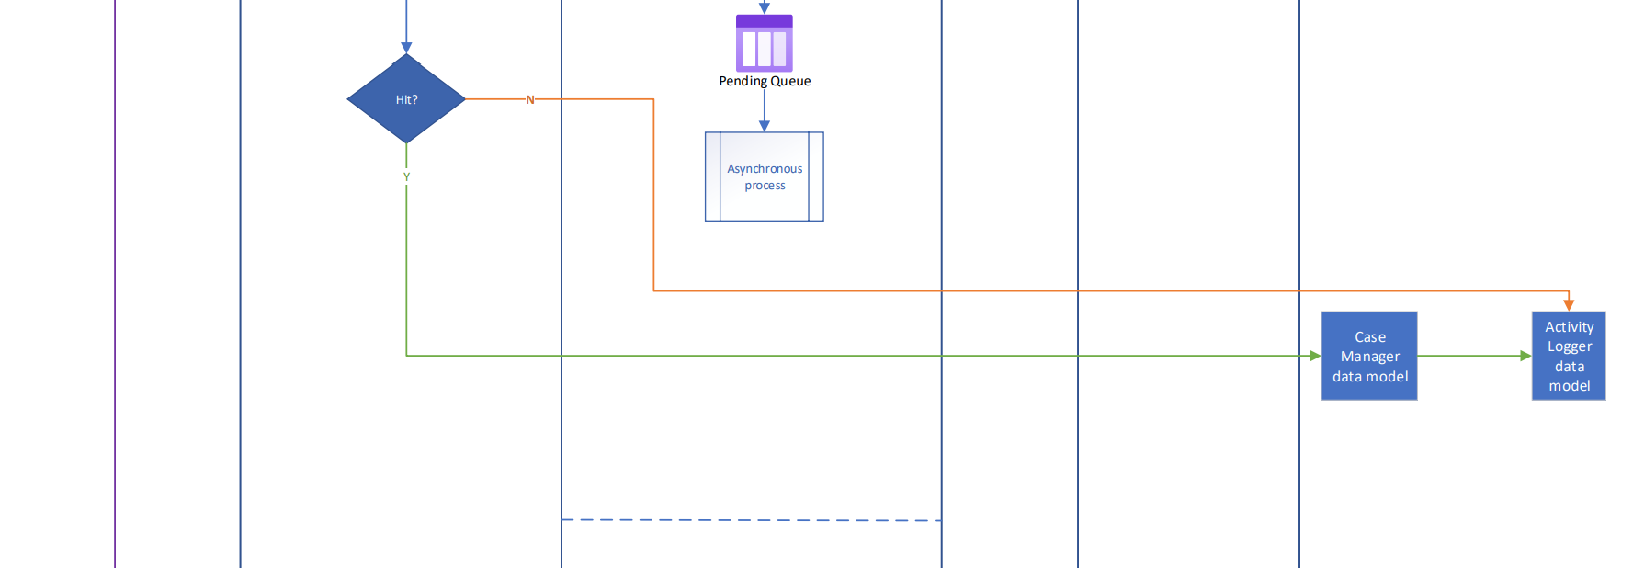

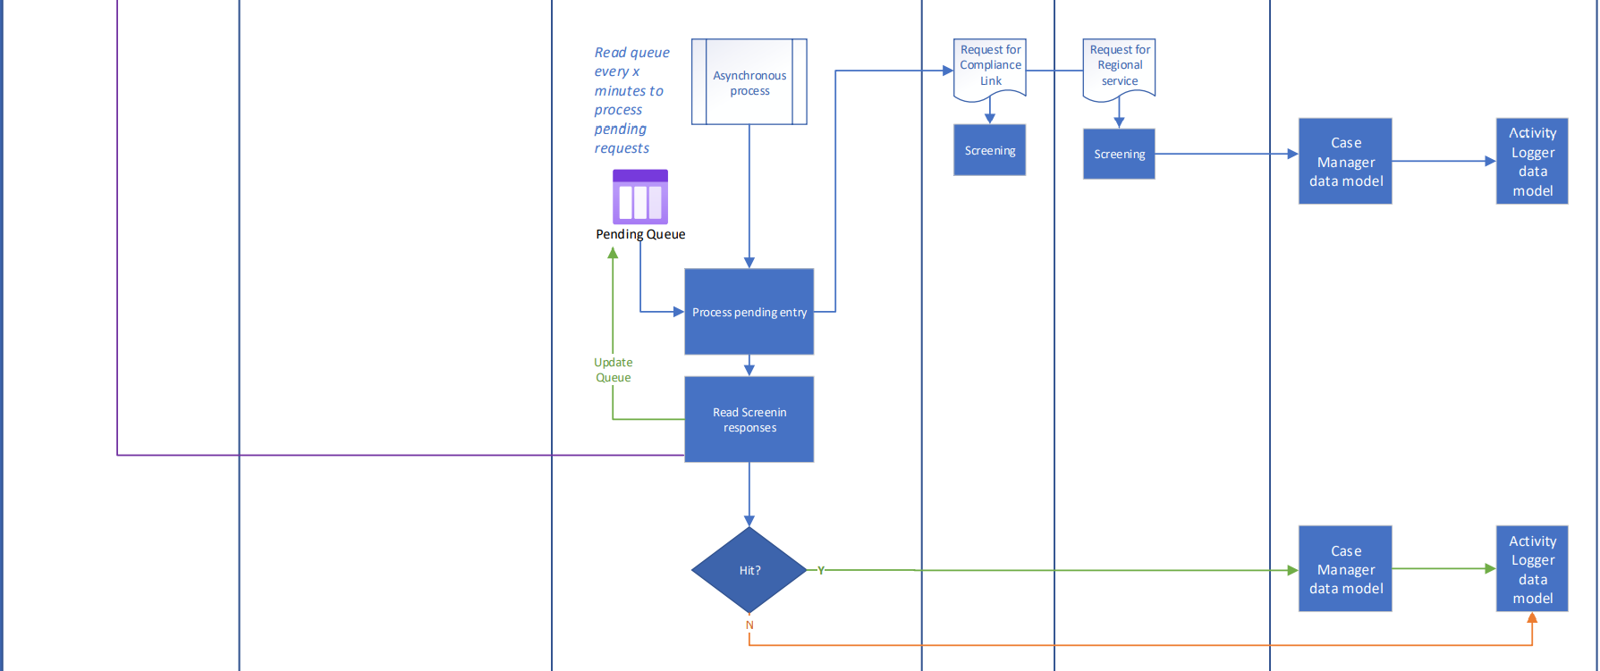

*Component Diagram*



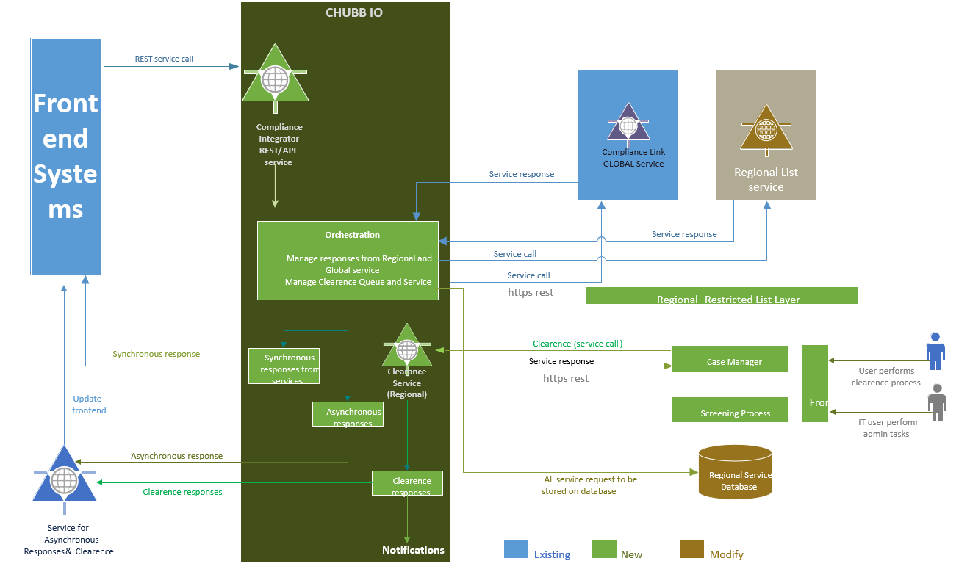

### Sequence Diagram – Online Screening (Sync call)

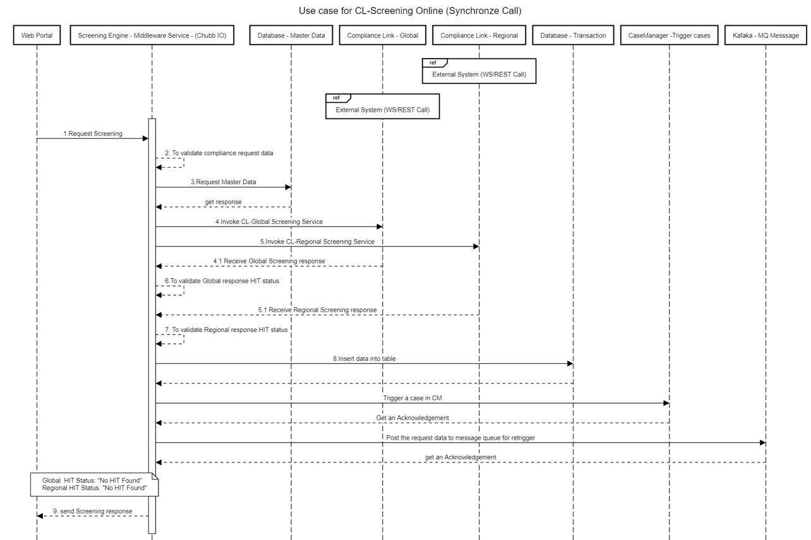

### Sequence Diagram – Online Screening (ASync call)

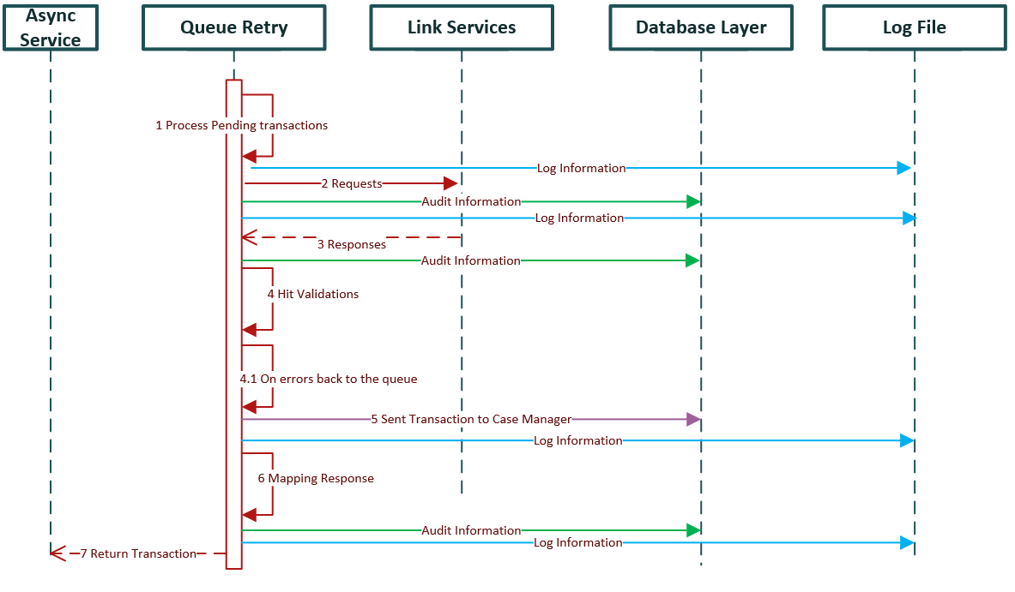

### Class Diagram

### Input / Request data

The source system will invoke the complaince link API Service (OnlineScreening) and will send the attached data as a input request parameter for the call , which is an JSON format.



Note: Refer the section 5.9.1 for request paramter in details.

### Master Data

**EntryTypeCode**

|  |  |
| --- | --- |
| **ESREntryTypeCode** | **Description** |
| *10* | *Newline* |
| *11* | *Renewal/Conversion* |
| *19* | *Pre-Renewal Quote* |
| *20* | *Renewal* |
| *30* | *Endorsement* |
| *31* | *Term Extension* |
| *40* | *Cancellation* |
| *AAA* | *FNOL* |
| *AAB* | *Claim Payment* |
| *AAC* | *Clm Bulk Pymt* |
| *700* | *Close Claim* |
| *705* | *Clsd Incident* |
| *720* | *Reopen Claim* |
| *725* | *Reopen Clm-Aggr* |
| *990* | *Deleted Clm* |

**RoleTypeCode**

|  |  |
| --- | --- |
| **ESRRoleTypeCode** | **Description** |
| *1* | *Claimant* |
| *2* | *Payee* |
| *3* | *Insured* |
| *4* | *Loss Location* |
| *5* | *Subject of Insurance* |
| *6* | *Port of Departure* |
| *7* | *Port of Destination* |
| *8* | *OVERRIDE PAYEE* |
| *9* | *MAIL TO ADDRESS* |
| *10* | *Trans Shipment Port* |
| *11* | *Insured Location* |
| *12* | *Driver* |
| *13* | *Account* |
| *14* | *Principal* |
| *15* | *Obligee* |
| *16* | Mortgagee |
| *17* | Additional Interest |
| *18* | Trust |
| *19* | Limited Liability Company |
| *20* | Business Pursuit |
| *21* | Interested Party |
| *22* | Registrant |
| *23* | Additional Insured |
| *24* | Claimant Address |
| *25* | Payee Address |
| *26* | Vessel Name |
| *27* | Vessel IMO Number |
| *28* | Vessel Owner |
| *29* | Vessel Operator |
| *30* | Columbian NIT |
| *31* | Organization Name |

**CountryCode, CountryName and CountryAbbreviation**

The table below enumerates the country values. You are required to inform at least one of the country fields (code, name or abbreviation).

|  |  |  |
| --- | --- | --- |
| **Code** | **Country Name** | **Country Abbreviation** |
| *AA* | *ALBANIA* | *ALBA* |
| *AD* | *ANDORRA* | *ANDO* |
| *AF* | *AFGHANISTAN* | *AFGH* |
| *AG* | *ANTIGUA AND BARBUDA* | *TGUA* |
| *AI* | *DJIBOUTI* | *DJIB* |
| *AM* | *ARMENIA* | *ARME* |
| *AO* | *ANGOLA* | *ANGO* |
| *AQ* | *ANTARCTICA* | *ANTA* |
| *AW* | *ARUBA* | *ARUB* |
| *AX* | *ALAND ISLANDS* | *ALAI* |
| *BA* | *BOSNIA* | *BOSN* |
| *BD* | *BANGLADESH* | *BANG* |
| *BF* | *BURKINA FASO* | *BUFA* |
| *BG* | *BULGARIA* | *BULG* |
| *BI* | *BURUNDI* | *BURU* |
| *BL* | *SAINT-BARTHELEMY* | *STBL* |
| *BN* | *BRUNEI* | *BRUN* |
| *BT* | *BHUTAN* | *BHUT* |
| *BV* | *BOUVET ISLAND* | *BOUV* |
| *BW* | *BOTSWANA* | *BOTS* |
| *BY* | *BELARUS* | *BELA* |
| *BZ* | *BELIZE* | *BELI* |
| *CC* | *COCOS ISLANDS* | *COCO* |
| *CD* | *CONGO, DEM REPUB* | *CDR* |
| *CF* | *CENTRAL AFRICAN REP* | *CAR* |
| *CI* | *IVORY COAST* | *IVOR* |
| *CK* | *COOK ISLANDS* | *COOK* |
| *CM* | *CAMEROON* | *CAME* |
| *CN* | *CAYMAN ISLANDS* | *CAYM* |
| *CV* | *CAPE VERDE IS* | *CVI* |
| *CW* | *CURACAO* | *CURA* |
| *CX* | *CHRISTMAS ISLAND* | *CHRI* |
| *CY* | *CYPRUS* | *CYPR* |
| *CZ* | *CZECH REPUBLIC* | *CZEC* |
| *DM* | *DOMINICA* | *DOMA* |
| *DY* | *BENIN* | *BENI* |
| *EE* | *ESTONIA* | *ESTO* |
| *EH* | *SPANISH SAHARA* | *SAHA* |
| *ER* | *ERITREA* | *ERIT* |
| *ET* | *ETHIOPIA* | *ETHI* |
| *FI* | *FINLAND* | *FINL* |
| *FJ* | *FIJI* | *FIJI* |
| *FK* | *FALKLAND ISLANDS* | *FALK* |
| *FM* | *MICRONESIA* | *MICR* |
| *FO* | *FAEROE ISLANDS* | *FAER* |
| *GD* | *GRENADA* | *GREN* |
| *GF* | *FRENCH GUIANA* | *GUIA* |
| *GG* | *GUERNSEY* | *GUER* |
| *GI* | *GIBRALTAR* | *GIBR* |
| *GL* | *GREENLAND* | *GRED* |
| *GM* | *GAMBIA* | *GAMB* |
| *GP* | *GUADELOUPE* | *GUAD* |
| *GQ* | *EQUATORIAL GUINEA* | *EQUA* |
| *GS* | *SOUTH SANDWICH* | *SSI* |
| *GW* | *GUINEA-BISSAU* | *GUBI* |
| *GY* | *GUYANA* | *GUYA* |
| *HM* | *HEARD & MCDONALD IS* | *HMI* |
| *HR* | *CROATIA* | *CROA* |
| *HU* | *HUNGARY* | *HUNG* |
| *IM* | *ISLE OF MAN* | *ISLM* |
| *IO* | *BRITISH INDIAN* | *BIOT* |
| *IQ* | *IRAQ* | *IRAQ* |
| *IS* | *ICELAND* | *ICEL* |
| *JE* | *JERSEY* | *JERS* |
| *JO* | *JORDAN* | *JORD* |
| *KG* | *KYRGYZSTAN* | *KYGY* |
| *KH* | *CAMBODIA* | *CAMB* |
| *KI* | *KIRIBATI* | *KIRI* |
| *KM* | *COMORO ISLANDS* | *COMO* |
| *KN* | *ST KITTS-NEVIS* | *STKI* |
| *KP* | *NORTH KOREA* | *NKOR* |
| *KZ* | *KAZAKHSTAN* | *KAZA* |
| *LC* | *ST LUCIA* | *STLU* |
| *LI* | *LIECHTENSTEIN* | *LIEC* |
| *LK* | *SRI LANKA* | *SRIL* |
| *LO* | *LAOS* | *LAOS* |
| *LS* | *LESOTHO* | *LESO* |
| *LT* | *LITHUANIA* | *LITH* |
| *LU* | *LUXEMBOURG* | *LUXE* |
| *LV* | *LATVIA* | *LATV* |
| *MC* | *MACAO* | *MACA* |
| *MF* | *SAINT-MARTIN (FR)* | *STMA* |
| *MG* | *MADAGASCAR* | *MADA* |
| *MH* | *MONTSERRAT* | *MTSR* |
| *MK* | *MONGOLIA* | *MONG* |
| *ML* | *MALI* | *MALI* |
| *MM* | *MALTA* | *MALT* |
| *MP* | *MONACO* | *MONA* |
| *MQ* | *MARTINIQUE* | *MART* |
| *MR* | *MAURITANIA* | *MRTN* |
| *MU* | *MAURITIUS* | *MRTS* |
| *MV* | *MALDIVES* | *MALD* |
| *MW* | *MALAWI* | *MALW* |
| *MZ* | *MOZAMBIQUE* | *MOZA* |
| *NA* | *NAMIBIA* | *NAMI* |
| *NG* | *NIGER* | *NIGR* |
| *NI* | *NORFOLK ISLAND* | *NORF* |
| *NK* | *NEW CALEDONIA* | *NCAL* |
| *NP* | *NEPAL* | *NEPA* |
| *NR* | *NAURU* | *NAUR* |
| *PF* | *FRENCH POLYNESIA* | *POLY* |
| *PG* | *PAPUA NEW GUINEA* | *PAPU* |
| *PL* | *POLAND* | *POLA* |
| *PM* | *ST PIERRE/MIQUELON* | *STPI* |
| *PN* | *PITCAIRN ISLANDS* | *PITC* |
| *PS* | *PALESTINIAN TER* | *PLST* |
| *PW* | *PALAU* | *PALA* |
| *PY* | *PARAGUAY* | *PARA* |
| *QA* | *QATAR* | *QATA* |
| *RC* | *MOROCCO* | *MORO* |
| *RE* | *REUNION* | *REUN* |
| *RO* | *ROMANIA* | *ROMA* |
| *RU* | *RUSSIA* | *RUSS* |
| *RW* | *RWANDA* | *RWAN* |
| *SB* | *SOLOMON IS* | *SOLO* |
| *SE* | *SEYCHELLES* | *SEYC* |
| *SH* | *ST HELENA* | *STHE* |
| *SI* | *SLOVENIA* | *SLON* |
| *SJ* | *SVALBARD-JAN MAYEN* | *SJMI* |
| *SL* | *SIERRA LEONE* | *SIER* |
| *SM* | *SAN MARINO* | *SMAR* |
| *SN* | *SENEGAL* | *SENE* |
| *SO* | *SOMALIA* | *SOMA* |
| *SR* | *SURINAM* | *SURI* |
| *ST* | *SAO TOME & PRINCIPE* | *STP* |
| *SV* | *SUDAN* | *SUDA* |
| *SX* | *SINT MAARTEN (DU)* | *STMD* |
| *SY* | *SYRIA* | *SYRI* |
| *SZ* | *SWAZILAND* | *SWAZ* |
| *TC* | *TURKS & CAICOS IS* | *TCI* |
| *TD* | *CHAD* | *CHAD* |
| *TF* | *FRENCH SOUTHERN TER* | *FRST* |
| *TG* | *TOGO* | *TOGO* |
| *TJ* | *TAJIKISTAN* | *TAJI* |
| *TK* | *TOKELAU ISLANDS* | *TOKE* |
| *TL* | *TIMOR-LESTE* | *TIML* |
| *TM* | *TURKMENISTAN* | *TURM* |
| *TO* | *TONGA* | *TONG* |
| *TU* | *TUNISIA* | *TUNI* |
| *TV* | *TUVALU* | *TUVA* |
| *TZ* | *TANZANIA* | *TANZ* |
| *UA* | *UKRAINE* | *UKRA* |
| *UG* | *UGANDA* | *UGAN* |
| *UM* | *US MINOR OUTLYING I* | *USMO* |
| *UY* | *URUGUAY* | *URUG* |
| *UZ* | *UZBEKISTAN* | *UZBE* |
| *VC* | *ST VINCENT* | *STVI* |
| *VG* | *BRIT VIRGIN IS* | *BVI* |
| *VN* | *VIETNAM* | *VIET* |
| *VS* | *VATICAN CITY STATE* | *VATI* |
| *VU* | *VANUATU* | *VANU* |
| *WF* | *WALLIS & FUTUNA IS* | *WFI* |
| *WS* | *WESTERN SAMOA* | *WSAM* |
| *XA* | *ANGUILLA* | *ANGU* |
| *XB* | *AZERBAIJAN* | *AZER* |
| *XC* | *MOLDOVA* | *MOLD* |
| *XD* | *MARSHALL IS* | *MARS* |
| *XE* | *NORTH MARIANA* | *NMI* |
| *XF* | *MAYOTTE* | *MAYO* |
| *XG* | *GEORGIA REPUBLIC* | *GEOR* |
| *XH* | *SLOVAKIA* | *SLVK* |
| *XI* | *MACEDONIA* | *MACE* |
| *XJ* | *NIUE ISLAND* | *NIUE* |
| *XK* | *MYANMAR* | *MYAN* |
| *XL* | *BONAIRE,ST EUST* | *BSES* |
| *55* | *NETHERLANDS* | *NETH* |
| *56* | *PHILIPPINE ISLANDS* | *PHIL* |
| *57* | *UNITED KINGDOM U* | *K* |
| *58* | *PUERTO RICO P* | *R* |
| *59* | *BELGIUM* | *BELG* |
| *6A* | *ARGENTINA* | *ARGT* |
| *6B* | *BRAZIL* | *BRAZ* |
| *6C* | *CHILE* | *CHIL* |
| *6D* | *CONGO* | *CONG* |
| *6E* | *ECUADOR* | *ECUA* |
| *6F* | *EL SALVADOR EL* | *S* |
| *6G* | *GHANA* | *GHAN* |
| *6H* | *GUATEMALA* | *GUAT* |
| *6I* | *SERBIA* | *SRB* |
| *6J* | *HONDURAS* | *HOND* |
| *6K* | *HONG KONG H* | *K* |
| *6L* | *IRAN* | *IRAN* |
| *6M* | *ISRAEL* | *ISRA* |
| *6P* | *KENYA* | *KENY* |
| *6Q* | *LEBANON* | *LEBA* |
| *6R* | *LIBERIA* | *LIBE* |
| *6S* | *LIBYA* | *LIBY* |
| *6T* | *MALAYSIA* | *MALY* |
| *6U* | *TAIWAN* | *TAIW* |
| *6V* | *NIGERIA* | *NIGA* |
| *6W* | *PANAMA* | *PANA* |
| *6X* | *PERU* | *PERU* |
| *6Y* | *ZIMBABWE* | *ZIMB* |
| *6Z* | *THAILAND* | *THAI* |
| *60* | *CUBA* | *CUBA* |
| *61* | *GUAM* | *GUAM* |
| *62* | *COLOMBIA* | *CBIA* |
| *63* | *VIRGIN ISLANDS U.S. V* | *I* |
| *64* | *VENEZUELA* | *VENE* |
| *65* | *MEXICO* | *MEX* |
| *66* | *BAHAMAS* | *BAHA* |
| *67* | *COSTA RICA* | *COST* |
| *68* | *JAMAICA* | *JAMA* |
| *69* | *TRINIDAD & TOBAGO* | *TRIN* |
| *7A* | *DENMARK* | *DENM* |
| *7B* | *FRANCE* | *FRAN* |
| *7C* | *GREECE* | *GREC* |
| *7D* | *INDIA* | *INDI* |
| *7E* | *IRELAND* | *IRE* |
| *7F* | *ITALY* | *ITAL* |
| *7G* | *NORWAY* | *NORW* |
| *7H* | *PAKISTAN* | *PAKS* |
| *7J* | *PORTUGAL* | *PORT* |
| *7K* | *SINGAPORE* | *SING* |
| *7L* | *SPAIN* | *SPAI* |
| *7M* | *SWEDEN* | *SWED* |
| *7N* | *SWITZERLAND* | *SWIT* |
| *7P* | *TURKEY* | *TURK* |
| *7Q* | *GERMANY* | *GERM* |
| *7R* | *NEW ZEALAND* | *NZEA* |
| *7S* | *DOMINICAN REPUBLIC D* | *R* |
| *7T* | *SAUDI ARABIA* | *SAUD* |
| *7V* | *YEMEN* | *YEME* |
| *7W* | *HAITI* | *HAIT* |
| *7Y* | *BERMUDA* | *BERM* |
| *7Z* | *ZAMBIA* | *ZAMB* |
| *75* | *SOUTH KOREA* | *SKOR* |
| *77* | *JAPAN* | *JAPA* |
| *79* | *AUSTRALIA* | *ASTL* |
| *8A* | *UNITED STATES* | *USA* |
| *8B* | *CANADA* | *CAN* |
| *8C* | *PEOPLES REP – CHINA* | *PRC* |
| *8D* | *UNITED ARAB EMIRATE* | *UAE* |
| *8E* | *ALGERIA* | *ALGE* |
| *8F* | *AUSTRIA* | *ASTR* |
| *8G* | *BAHRAIN* | *BAHR* |
| *8H* | *BARBADOS* | *BARB* |
| *8J* | *BOLIVIA* | *BOLI* |
| *8K* | *EGYPT* | *EGYP* |
| *8L* | *GABON* | *GABO* |
| *8M* | *OMAN* | *OMAN* |
| *8N* | *NICARAGUA* | *NICA* |
| *8P* | *KUWAIT* | *KUWA* |
| *8Q* | *GUINEA* | *GUIN* |
| *8R* | *INDONESIA* | *INDO* |
| *8V* | *AMERICAN SAMOA* | *ASAM* |
| *8W* | *MONTENEGRO* | *MNE* |
| *81* | *SOUTH AFRICA* | *SAFR* |
| *95* | *FGN NOC DOMESTIC* | *FNDM* |
| *96* | *FOREIGN N.O.C.* | *FNOC* |

### Compliance link – Global Screening

This is an existant service, our orchestration component in Chubb IO Framework will invoque this service and waiting his answer.

There are three different request:

<https://nasit.chubbdigital.com/servicing.es-screening/CLClaim>  
<http://nasit.chubbdigital.com/enterprise.servicing.economicsanctions/clpolicy>  
<https://nasit.chubbdigital.com/servicing.es-screening/CLClaimPayment>

* + 1. CLPolicy: There are four unique search entity types, Individual, Organization, Vessel and Location. Each search string or location provided in the request will be screened to ensure that none of the search string values or locations associated to the policy has been identified as a potential economic sanction risk.
    2. CLClaim: There are four unique search entity types- Individual, Organization, Vessel and Location. Each search string or location provided in the request will be screened to ensure that none of the search string values or locations associated to the claim has been identified as a potential economic sanction risk.
    3. CLClaimPayment: There are two possible search string entity types, an Individual payee or an Organization payee. Only one of these can be associated to a single payment. Each payment transaction payee search string provided in the request for a claim will be screened to determine if the payee has been identified as a potential economic sanction risk

#### CLPolicy description Input Request:

| **Element Name** | **Required?** | **Format** | **Default** | **Length** | |
| --- | --- | --- | --- | --- | --- |
|  |  | Min | Max |
| SourceSystemKeyId | R | Character |  | 1 | 100 |
| UserId | R | Character |  | 7 | 8 |
| SystemId | C | Character |  | 2 | 2 |
| SourceSystemName | C | Character |  | 1 | 8 |
| EntryTypeCode | C | Character |  |  | 3 |
| SourceSystemTransaction TypeName | C | Character |  | 1 | 40 |
| ESRProgramName | R | Character |  | 1 | 8 |
| ContactName | O | Character |  | 1 | 80 |
| ContactPhoneNumber | O | Character |  | 1 | 20 |
| BranchCode | R | Character |  | 2 | 4 |
| ESRFileSearchCode | C | Character |  | 3 | 3 |
| ESRResolutionTeamName | C | Character |  | 1 | 20 |
| SourceSystemTransactionId | O | Character |  | 1 | 26 |
|  |  |  |  |  |  |
|  |  |  |  |  |  |
| **EconomicSanctionRiskIndividual/ [ ]** (Array) | | | | | |
| SourceSystemReferenceText | C | Character |  | 1 | 120 |
| SourceSystemSearchType Description | O | Character |  | 1 | 50  See Note |
| SourceSystemSearch Identifier | O | Character |  | 1 | 120  See Note |
| ESRRoleTypeCode [ ]  (Array of up to five) | C | Character |  | 3 | 3 |
| ESRFileSearchCode | C | Character |  | 3 | 3 |
| ESRResolutionTeamName | C | Character |  | 1 | 20 |
| SearchEntityValueText | C | Character |  | 1 | 600 |
| IndividualFullName | C | Character |  | 1 | 600 |
| PrefixName | O | Character |  | 1 | 08 |
| GivenName | C | Character |  | 1 | 40 |
| MiddleInitial | O | Character |  | 1 | 30 |
| Surname | C | Character |  | 1 | 100 |
| NameSuffix | O | Character |  | 1 | 04 |
| IndividualBirthDate | O | Date |  |  |  |
| OccupationDescription | O | Character |  | 1 | 20 |
| EmployerName | O | Character |  | 1 | 50 |
| **Address/** | | | | | |
| AddressLine1 | O | Character |  | 1 | 60 |
| AddressLine2 | O | Character |  | 1 | 60 |
| CityName | O | Character |  | 1 | 35 |
| StateOrProvinceCode | O | Character |  | 2 | 3 |
| PostalCode | O | Character |  | 1 | 32 |
| CountryName | O | Character |  | 2 | 19 |
| **Driver/** | | | | | |
| DriverLicenseNumber | O | Character |  | 1 | 19 |
| DriverPostalState Abbreviation | O | Character |  | 2 | 3 |
| DriverLicenseCountry Code | O | Character |  | 2 | 3 |
| DriverLicensedDate |  | Date |  |  |  |
| DriverLicenseCopy Indicator | O | Character |  | 1 | 1 |
| **EconomicSanctionRiskPassport/ [ ]** (Array of up to six) | | | | | |
| PassportIssueCountry Code | O | Character |  | 2 | 3 |
| PassportNumber | O | Character |  | 1 | 30 |
|  |  |  |  |  |  |
|  |  |  |  |  |  |
| **EconomicSanctionRiskOrganization/ [ ]** (Array) | | | | | |
| SourceSystemReferenceText | C | Character |  | 1 | 120 |
| SourceSystemSearchType Description | O | Character |  | 1 | 50  See Note |
| SourceSystemSearch Identifier | O | Character |  | 1 | 120  See Note |
| ESRRoleTypeCode [ ]  (Array of up to five) | C | Character |  | 3 | 3 |
| ESRFileSearchCode | O | Character |  | 3 | 3 |
| ESRResolutionTeamName | O | Character |  | 1 | 20 |
| SearchEntityValueText | C | Character |  | 1 | 600 |
| ESROrgName | C | Character |  | 1 | 600 |
| OrgIncDate | O | Date |  |  |  |
| OrgTypeDescription | O | Character |  | 1 | 30 |
| OrgIncStateOrProvinceCode | O | Character |  | 2 | 3 |
| OrgTaxIdNumber | O | Character |  | 1 | 09 |
| **Address/** | | | | | |
| AddressLine1 | O | Character |  | 1 | 60 |
| AddressLine2 | O | Character |  | 1 | 60 |
| CityName | O | Character |  | 1 | 35 |
| StateOrProvinceCode | O | Character |  | 2 | 3 |
| PostalCode | O | Character |  | 1 | 32 |
| CountryName | O | Character |  | 2 | 19 |
|  |  |  |  |  |  |
|  |  |  |  |  |  |
| **EconomicSanctionRiskVessel/ [ ]** (Array) | | | | | |
| SourceSystemReferenceText | C | Character |  | 1 | 120 |
| SourceSystemSearchType Description | O | Character |  | 1 | 50  See Note |
| SourceSystemSearch Identifier | O | Character |  | 1 | 120  See Note |
| ESRRoleTypeCode [ ]  (Array of up to five) | C | Character |  | 3 | 3 |
| ESRFileSearchCode | C | Character |  | 3 | 3 |
| ESRResolutionTeamName | C | Character |  | 1 | 20 |
| SearchEntityValueText | C | Character |  | 1 | 600 |
| ESRVesselName | C | Character |  | 1 | 600 |
| VesselTypeCode | O | Character |  | 1 | 3 |
| VesselGrossWeight | O | Character |  | 1 | 9 |
| VesselDeadWeight | O | Character |  | 1 | 9 |
| VesselCountryCode | O | Character |  | 2 | 3 |
| **Address/** | | | | | |
| AddressLine1 | O | Character |  | 1 | 60 |
| AddressLine2 | O | Character |  | 1 | 60 |
| CityName | O | Character |  | 1 | 35 |
| StateOrProvinceCode | O | Character |  | 2 | 3 |
| PostalCode | O | Character |  | 1 | 32 |
| CountryName | O | Character |  | 2 | 19 |
|  |  |  |  |  |  |
|  |  |  |  |  |  |
| **EconomicSanctionRiskLocation/ [ ]** (Array) | | | | | |
| SourceSystemReferenceText | C | Character |  | 1 | 120 |
| SourceSystemSearchType Description | O | Character |  | 1 | 50  See Note |
| SourceSystemSearch Identifier | O | Character |  | 1 | 120  See Note |
| ESRRoleTypeCode [ ]  (Array of up to five) | C | Character |  | 3 | 3 |
| ESRFileSearchCode | C | Character |  | 3 | 3 |
| ESRResolutionTeamName | C | Character |  | 1 | 20 |
| SearchEntityValueText | C | Character |  | 1 | 600 |
| ESRLocationName | C | Character |  | 1 | 600 |
| **Address/** | | | | | |
| AddressLine1 | O | Character |  | 1 | 60 |
| AddressLine2 | O | Character |  | 1 | 60 |
| CityName | O | Character |  | 1 | 35 |
| StateOrProvinceCode | O | Character |  | 2 | 3 |
| PostalCode | O | Character |  | 1 | 32 |
| CountryName | O | Character |  | 2 | 19 |
|  |  |  |  |  |  |
|  |  |  |  |  |  |
| **EconomicSanctionRiskPolicyInformation/** | | | | | |
| PolicyNumber | O | Character |  | 1 | 12 |
| InceptionDate | O | Date |  |  |  |
| ExpirationDate | O | Date |  |  |  |
| ControlNumber | O | Character |  | 1 | 8 |
| ExistingBusinessIndicator | O | Character |  | 1 | 1 |
| CertificateNumber | O | Character |  | 1 | 12 |
| OfferingNumber | O | Character |  | 1 | 12 |
| OfferingDB2Timestamp | O | Character |  | 26 | 26 |
| PolicyTypeCode | O | Character |  | 2 | 2 |
| PolicyTypeSubCode | O | Character |  | 2 | 2 |
| CustomerGroupCode | O | Character |  | 4 | 4 |
| ProducingBranchNumber | O | Character |  | 4 | 4 |
| DepartmentNumber | O | Character |  | 4 | 6 |
| InsurerNumber | O | Character |  | 1 | 2 |
| InsuredName | O | Character |  | 1 | 80 |
| WIPInsuredNumber | O | Character |  | 1 | 8 |
| CPNumber | O | Character |  | 1 | 12 |
| ProducerName | O | Character |  | 1 | 80 |
| ProducerNumber | O | Character |  | 5 | 7 |
| ProducerSubNumber | O | Character |  | 3 | 5 |
| PhoneNumber | O | Character |  | 1 | 14 |
| ESRProducerContactName | O | Character |  | 1 | 40 |
|  |  |  |  |  |  |

Response

| **Element Name** | **Expected Results for each name identified as a Risk** |
| --- | --- |
| ESRRequestId | Only populated when one or more “Hits” occur. This is the Compliance Link Transaction ID assigned to the request. It is displayed as the Transaction ID in Compliance Link. |
| **ESRIdentifiedRisksDetail/ [ ]** | Array, one occurrence is returned for each name identified as a risk in the request. |
| ESRSourceFileName [ ] | This returns the file abbreviation of each file that identified the name as a risk. See Appendix B for list of possible values. |
| **EconomicSanctionRiskIndividual/** | Returns the Individual keys assigned to the risk and repeats the input Individual details. |
| REPEAT OF INPUT ELEMENTS for Individual | Always populated if valued on input for the identified risk. |
| **EconomicSanctionRiskOrganization/** | Returns the Organization keys assigned to the risk and repeats the input Organization details. |
| *REPEAT OF INPUT ELEMENTS for Organization* | Always populated if valued on input for the identified risk. |
| **EconomicSanctionRiskVessel/** | Returns the Vessel keys assigned to the risk and repeats the input Vessel details. |
| *REPEAT OF INPUT ELEMENTS for Vessel* | Always populated if valued on input for the identified risk. |
| **EconomicSanctionRiskLocation/** | Returns the Location keys assigned to the risk and repeats the input Location details. |
| *REPEAT OF INPUT ELEMENTS for Location* | Always populated if valued on input for the identified risk. |
|  |  |
| **ESRStatusInformation/** | Returns the status of the Search and Update process. |
| StatusCode | Always populated.  S = Successful  (Screening completed)  E = Error (One or more entities encountered an error). |
| **ESRError/ [ ]** | Valued for each updated risk when there is an error or warning message. |
| ErrorCode | This is an error number |
| ErrorDescription | This is the error message |
| ErrorSeverityLevel | E = Error  I = Information  W = Warning |
| ErrorSourceIdentifier |  |

#### CLClaim description Input Request:

| **Element Name** | **Required?** | **Format** | **Default** | **Length** | |
| --- | --- | --- | --- | --- | --- |
|  |  | Min | Max |
| SourceSystemKeyId | R | Character |  | 1 | 100 |
| UserId | R | Character |  | 7 | 8 |
| SystemId | C | Character |  | 2 | 2 |
| SourceSystemName | C | Character |  | 1 | 8 |
| EntryTypeCode | C | Character |  |  | 3 |
| SourceSystemTransaction TypeName | C | Character |  | 1 | 40 |
| ESRProgramName | R | Character |  | 1 | 8 |
| ContactName | O | Character |  | 1 | 80 |
| ContactPhoneNumber | O | Character |  | 1 | 20 |
| BranchCode | R | Character |  |  | 4 |
| ESRFileSearchCode | C | Character |  | 3 | 3 |
| ESRResolutionTeamName | C | Character |  | 1 | 20 |
| SourceSystemTransactionId | O | Character |  | 1 | 26 |
|  |  |  |  |  |  |
|  |  |  |  |  |  |
| **EconomicSanctionRiskIndividual/ [ ]** (Array) | | | | | |
| SourceSystemReferenceText | C | Character |  | 1 | 120 |
| SourceSystemSearchType Description | O | Character |  | 1 | 50  See Note |
| SourceSystemSearch Identifier | O | Character |  | 1 | 120  See Note |
| ESRRoleTypeCode [ ]  (Array of up to five) | C | Character |  | 3 | 3 |
| ESRFileSearchCode | C | Character |  | 3 | 3 |
| ESRResolutionTeamName | C | Character |  | 1 | 20 |
| SearchEntityValueText | C | Character |  | 1 | 600 |
| IndividualFullName | C | Character |  | 1 | 600 |
| PrefixName | O | Character |  | 1 | 08 |
| GivenName | C | Character |  | 1 | 40 |
| MiddleInitial | O | Character |  | 1 | 30 |
| Surname | C | Character |  | 1 | 100 |
| NameSuffix | O | Character |  | 1 | 04 |
| IndividualBirthDate | O | Date |  |  |  |
| OccupationDescription | O | Character |  | 1 | 20 |
| EmployerName | O | Character |  | 1 | 50 |
| **Address/** | | | | | |
| AddressLine1 | O | Character |  | 1 | 60 |
| AddressLine2 | O | Character |  | 1 | 60 |
| CityName | O | Character |  | 1 | 35 |
| StateOrProvinceCode | O | Character |  | 2 | 3 |
| PostalCode | O | Character |  | 1 | 32 |
| CountryName | O | Character |  | 2 | 19 |
| **Driver/** | | | | | |
| DriverLicenseNumber | O | Character |  | 1 | 19 |
| DriverPostalState Abbreviation | O | Character |  | 2 | 3 |
| DriverLicenseCountry Code | O | Character |  | 2 | 3 |
| DriverLicensedDate |  | Date |  |  |  |
| DriverLicenseCopy Indicator | O | Character |  | 1 | 1 |
| **EconomicSanctionRiskPassport/ [ ]** (Array of up to six) | | | | | |
| PassportIssueCountry Code | O | Character |  | 2 | 3 |
| PassportNumber | O | Character |  | 1 | 30 |
|  |  |  |  |  |  |
|  |  |  |  |  |  |
| **EconomicSanctionRiskOrganization/ [ ]** (Array) | | | | | |
| SourceSystemReferenceText | C | Character |  | 2 | 120 |
| SourceSystemSearchType Description | O | Character |  | 1 | 50  See Note |
| SourceSystemSearch Identifier | O | Character |  | 1 | 120  See Note |
| ESRRoleTypeCode [ ]  (Array of up to five) | C | Character |  | 3 | 3 |
| ESRFileSearchCode | C | Character |  | 3 | 3 |
| ESRResolutionTeamName | C | Character |  | 1 | 20 |
| SearchEntityValueText | C | Character |  | 1 | 600 |
| ESROrgName | C | Character |  | 2 | 600 |
| OrgIncDate | O | Date |  |  |  |
| OrgTypeDescription | O | Character |  | 2 | 30 |
| OrgIncStateOrProvinceCode | O | Character |  | 3 | 3 |
| OrgTaxIdNumber | O | Character |  | 1 | 9 |
| **Address/** | | | | | |
| AddressLine1 | O | Character |  | 1 | 60 |
| AddressLine2 | O | Character |  | 1 | 60 |
| CityName | O | Character |  | 1 | 35 |
| StateOrProvinceCode | O | Character |  | 2 | 3 |
| PostalCode | O | Character |  | 1 | 32 |
| CountryName | O | Character |  | 2 | 19 |
|  |  |  |  |  |  |
|  |  |  |  |  |  |
| **EconomicSanctionRiskVessel/ [ ]** (Array) | | | | | |
| SourceSystemReferenceText | C | Character |  | 1 | 120 |
| SourceSystemSearchType Description | O | Character |  | 1 | 50  See Note |
| SourceSystemSearch Identifier | O | Character |  | 1 | 120  See Note |
| ESRRoleTypeCode [ ]  (Array of up to five) | C | Character |  | 3 | 3 |
| ESRFileSearchCode | C | Character |  | 3 | 3 |
| ESRResolutionTeamName | C | Character |  | 1 | 20 |
| SearchEntityValueText | C | Character |  | 1 | 600 |
| ESRVesselName | C | Character |  | 1 | 600 |
| VesselTypeCode | O | Character |  | 1 | 3 |
| VesselGrossWeight | O | Character |  | 1 | 9 |
| VesselDeadWeight | O | Character |  | 1 | 9 |
| VesselCountryCode | O | Character |  | 2 | 3 |
| **Address/** | | | | | |
| AddressLine1 | O | Character |  | 1 | 60 |
| AddressLine2 | O | Character |  | 1 | 60 |
| CityName | O | Character |  | 1 | 35 |
| StateOrProvinceCode | O | Character |  | 2 | 3 |
| PostalCode | O | Character |  | 1 | 32 |
| CountryName | O | Character |  | 2 | 19 |
|  |  |  |  |  |  |
|  |  |  |  |  |  |
| **EconomicSanctionRiskLocation/ [ ]** (Array) | | | | | |
| SourceSystemReferenceText | C | Character |  | 1 | 120 |
| SourceSystemSearchType Description | O | Character |  | 1 | 50  See Note |
| SourceSystemSearch Identifier | O | Character |  | 1 | 120  See Note |
| ESRRoleTypeCode [ ]  (Array of up to five) | C | Character |  | 3 | 3 |
| ESRFileSearchCode | C | Character |  | 3 | 3 |
| ESRResolutionTeamName | C | Character |  | 1 | 20 |
| SearchEntityValueText | C | Character |  | 1 | 600 |
| ESRLocationName | C | Character |  | 1 | 600 |
| **Address/** | | | | | |
| AddressLine1 | O | Character |  | 1 | 60 |
| AddressLine2 | O | Character |  | 1 | 60 |
| CityName | O | Character |  | 1 | 35 |
| StateOrProvinceCode | O | Character |  | 2 | 3 |
| PostalCode | O | Character |  | 1 | 32 |
| CountryName | O | Character |  | 2 | 19 |
|  |  |  |  |  |  |
|  |  |  |  |  |  |
| **EconomicSanctionRiskClaimInformation/** | | | | | |
| ClaimOccurrenceNumber | O | Character |  | 1 | 6 |
| ClaimNumber | O | Character |  | 1 | 12 |
| ClaimLineFeatureNumber | O | Character |  | 1 | 3 |
| ClaimAdjusterUserId | O | Character |  | 7 | 8 |
| ClaimAdjusterName | O | Character |  | 1 | 80 |
| ClaimantName | O | Character |  | 1 | 80 |
| **FirstNoticeOfLossBranch/** | | | | | |
| BranchNumber | O | Character |  | 1 | 4 |
|  |  |  |  |  |  |
|  |  |  |  |  |  |
| **EconomicSanctionRiskPolicyInformation/** | | | | | |
| PolicyNumber | O | Character |  | 1 | 12 |
| InceptionDate | O | Date |  |  |  |
| ExpirationDate | O | Date |  |  |  |
| ControlNumber | O | Character |  | 1 | 8 |
| ExistingBusinessIndicator | O | Character |  | 1 | 1 |
| CertificateNumber | O | Character |  | 1 | 12 |
| OfferingNumber | O | Character |  | 1 | 12 |
| OfferingDB2Timestamp | O | Character |  | 26 | 26 |
| PolicyTypeCode | O | Character |  | 2 | 2 |
| PolicyTypeSubCode | O | Character |  | 2 | 2 |
| CustomerGroupCode | O | Character |  | 4 | 4 |
| ProducingBranchNumber | O | Character |  | 4 | 4 |
| DepartmentNumber | O | Character |  | 4 | 6 |
| InsurerNumber | O | Character |  | 1 | 2 |
| InsuredName | O | Character |  | 1 | 80 |
| WIPInsuredNumber | O | Character |  | 1 | 8 |
| CPNumber | O | Character |  | 1 | 12 |
| ProducerName | O | Character |  | 1 | 80 |
| ProducerNumber | O | Character |  | 5 | 7 |
| ProducerSubNumber | O | Character |  | 3 | 5 |
| PhoneNumber | O | Character |  | 1 | 14 |
| ESRProducerContactName | O | Character |  | 1 | 40 |

Response:

| **Element Name** | **Expected Results for each name identified as a Risk** |
| --- | --- |
| ESRRequestId | Only populated when one or more “Hits” occur. This is the Compliance Link Transaction ID assigned to the request. It is displayed as the Transaction ID in Compliance Link. |
| **ESRIdentifiedRisksDetail/ [ ]** | Array, one occurrence is returned for each name identified as a risk in the request. |
| ESRSourceFileName [ ] | This returns the file abbreviation of each file that identified the name as a risk. See Appendix B for list of possible values. |
| **EconomicSanctionRiskIndividual/** | Returns the Individual keys assigned to the risk and repeats the input Individual details. |
| REPEAT OF INPUT ELEMENTS for Individual | Always populated if valued on input for the identified risk. |
| **EconomicSanctionRiskOrganization/** | Returns the Organization keys assigned to the risk and repeats the input Organization details. |
| *REPEAT OF INPUT ELEMENTS for Organization* | Always populated if valued on input for the identified risk. |
| **EconomicSanctionRiskVessel/** | Returns the Vessel keys assigned to the risk and repeats the input Vessel details. |
| *REPEAT OF INPUT ELEMENTS for Vessel* | Always populated if valued on input for the identified risk. |
| **EconomicSanctionRiskLocation** | Returns the Location keys assigned to the risk and repeats the input Location details. |
| *REPEAT OF INPUT ELEMENTS for Location* | Always populated if valued on input for the identified risk. |
|  |  |
| **ESRStatusInformation/** | Returns the status of the Search and Update process. |
| StatusCode | Always populated.  S = Successful  (Search & Update completed)  E = Error (One or more updates encountered an error). |
| **ESRError/ [ ]** | Valued for each updated risk when there is an error or warning message. |
| ErrorCode | This is an error number |
| ErrorDescription | This is the error message |
| ErrorSeverityLevel | E = Error  I = Information  W = Warning |
| ErrorSourceIdentifier |  |
|  |  |

#### CLClaimPayment description Input Request:

| **Element Name** | **Required?** | **Format** | **Default** | **Length** | |
| --- | --- | --- | --- | --- | --- |
|  |  | Min | Max |
| SourceSystemKeyId | R | Character |  | 1 | 100 |
| UserId | R | Character |  | 7 | 8 |
| SystemId | C | Character |  | 2 | 2 |
| SourceSystemName | C | Character |  | 1 | 8 |
| EntryTypeCode | C | Character |  |  | 3 |
| SourceSystemTransaction TypeName | C | Character |  | 1 | 40 |
| ESRProgramName | R | Character |  | 1 | 8 |
| ContactName | O | Character |  | 1 | 80 |
| ContactPhoneNumber | O | Character |  | 1 | 20 |
| BranchCode | R | Character |  |  | 4 |
| ESRFileSearchCode | R | Character |  | 3 | 3 |
| ESRResolutionTeamName | R | Character |  | 1 | 20 |
| SourceSystemTransactionId | O | Character |  | 1 | 26 |
|  |  |  |  |  |  |
| **EconomicSanctionRiskPaymentInformation/ [ ]** (Array) | | | | | |
| PaymentRemittanceNumber | O | Character |  | 1 | 12 |
| PaymentAmount | O | Decimal |  | 1 | 17 |
| PaymentPriorityCode | O | Character |  | 1 | 1 |
| PaymentMethodDescription | O | Character |  | 1 | 10 |
| ESRTransactionStatus Description | O | Character |  | 1 | 20 |
|  |  |  |  |  |  |
|  |  |  |  |  |  |
| **EconomicSanctionRiskIndividualPayee/** | | | | | |
| SourceSystemReferenceText | C | Character |  | 1 | 120 |
| SourceSystemSearch  TypeDescription | O | Character |  | 1 | 50  See Note |
| SourceSystemSearch Identifier | O | Character |  | 1 | 120  See Note |
| ESRRoleTypeCode [ ]  (Array of up to five) | C | Character |  | 2 | 3 |
| SearchEntityValueText | C | Character |  | 1 | 600 |
| IndividualFullName | C | Character |  | 1 | 600 |
| PrefixName | O | Character |  | 1 | 08 |
| GivenName | C | Character |  | 1 | 40 |
| MiddleInitial | O | Character |  | 1 | 30 |
| Surname | C | Character |  | 1 | 100 |
| NameSuffix | O | Character |  | 1 | 04 |
| IndividualBirthDate | O | Date |  |  |  |
| OccupationDescription | O | Character |  | 1 | 20 |
| EmployerName | O | Character |  | 1 | 50 |
| **Address/** | | | | | |
| AddressLine1 | O | Character |  | 1 | 60 |
| AddressLine2 | O | Character |  | 1 | 60 |
| CityName | O | Character |  | 1 | 35 |
| StateOrProvince Code | O | Character |  | 2 | 3 |
| PostalCode | O | Character |  | 1 | 32 |
| CountryName | O | Character |  | 2 | 19 |
|  |  |  |  |  |  |
|  |  |  |  |  |  |
| **EconomicSanctionRiskOrganizationPayee/** | | | | | |
| SourceSystemReferenceText | C | Character |  | 1 | 120 |
| SourceSystemSearch  TypeDescription | O | Character |  | 1 | 50  See Note |
| SourceSystemSearch Identifier | O | Character |  | 1 | 120  See Note |
| ESRRoleTypeCode [ ]  (Array of up to five) | C | Character |  | 3 | 3 |
| SearchEntityValueText | C | Character |  | 1 | 600 |
| ESROrgName | C | Character |  | 1 | 600 |
| OrgIncDate | O | Date |  |  |  |
| OrgTypeDescription | O | Character |  | 1 | 30 |
| OrgIncStateOrProvince Code | O | Character |  | 1 | 03 |
| OrgTaxIdNumber | O | Character |  | 1 | 09 |
| **Address/** | | | | | |
| AddressLine1 | O | Character |  | 1 | 60 |
| AddressLine2 | O | Character |  | 1 | 60 |
| CityName | O | Character |  | 1 | 35 |
| StateOrProvince Code | O | Character |  | 2 | 3 |
| PostalCode | O | Character |  | 1 | 32 |
| CountryName | O | Character |  | 2 | 19 |
|  |  |  |  |  |  |
|  |  |  |  |  |  |
| **EconomicSanctionRiskClaimInformation/** | | | | | |
| ClaimOccurrenceNumber | O | Character |  | 1 | 6 |
| ClaimNumber | O | Character |  | 1 | 12 |
| ClaimLineFeatureNumber | O | Character |  | 1 | 3 |
| ClaimAdjusterUserId | O | Character |  | 7 | 8 |
| ClaimAdjusterName | O | Character |  | 1 | 80 |
| ClaimantName | O | Character |  | 1 | 80 |
| **FirstNoticeOfLossBranch/** | | | | | |
| BranchNumber | O | Character |  | 1 | 4 |
|  |  |  |  |  |  |
|  |  |  |  |  |  |
| **EconomicSanctionRiskPolicyInformation/** | | | | | |
| PolicyNumber | O | Character |  | 1 | 12 |
| InceptionDate | O | Date |  |  |  |
| ExpirationDate | O | Date |  |  |  |
| ControlNumber | O | Character |  | 1 | 8 |
| ExistingBusinessIndicator | O | Character |  | 1 | 1 |
| CertificateNumber | O | Character |  | 1 | 12 |
| OfferingNumber | O | Character |  | 1 | 12 |
| OfferingDB2Timestamp | O | Character |  | 26 | 26 |
| PolicyTypeCode | O | Character |  | 2 | 2 |
| PolicyTypeSubCode | O | Character |  | 2 | 2 |
| CustomerGroupCode | O | Character |  | 4 | 4 |
| ProducingBranchNumber | O | Character |  | 4 | 4 |
| DepartmentNumber | O | Character |  | 4 | 6 |
| InsurerNumber | O | Character |  | 1 | 2 |
| InsuredName | O | Character |  | 1 | 80 |
| WIPInsuredNumber | O | Character |  | 1 | 8 |
| CPNumber | O | Character |  | 1 | 12 |
| ProducerName | O | Character |  | 1 | 80 |
| ProducerNumber | O | Character |  | 5 | 7 |
| ProducerSubNumber | O | Character |  | 3 | 5 |
| PhoneNumber | O | Character |  | 1 | 14 |
| ESRProducerContactName | O | Character |  | 1 | 40 |
|  |  |  |  |  |  |

Response:

| **Element Name** | **Expected Results for each name identified as a Risk** |
| --- | --- |
| ESRRequestId | Only populated when one or more “Hits” occur. This is the Compliance Link Transaction ID assigned to the request. It is displayed as the Transaction ID in Compliance Link. |
| **ESRIdentifiedPaymentRisksDetail/ [ ]** | Array, one occurrence is returned for each name identified as a risk in the request. |
| ESRSourceFileName [ ] | This returns the file abbreviation of each file that identified the name as a risk. See Appendix B for list of possible values. |
| **EconomicSanctionRiskPaymentInformation/** | Returns the input values that identify the payment transaction. |
| PaymentRemittanceNumber | Repeat of input |
| PaymentAmount | Repeat of input |
| PaymentPriorityCode | Repeat of input |
| PaymentMethodDescription | Repeat of input |
| ESRTransactionStatusDescription | Repeat of input |
| **EconomicSanctionRiskIndividualPayee/** | Returns the Individual keys assigned to the risk and repeats the input Individual details. |
| REPEAT OF INPUT ELEMENTS for Individual payee | Always populated if valued on input for the identified risk. |
| **EconomicSanctionRiskOrganizationPayee/** | Returns the Organization keys assigned to the risk and repeats the input Organization details. |
| *REPEAT OF INPUT ELEMENTS for Organization payee* | Always populated if valued on input for the identified risk. |
|  |  |
| **ESRStatusInformation/** | Returns the status of the Search and Update process. |
| StatusCode | Always populated.  S = Successful  (Search & Update completed)  E = Error (One or more updates encountered an error). |
| **ESRError/ [ ]** | Valued for each updated risk when there is an error or warning message. |
| ErrorCode | This is an error number |
| ErrorDescription | This is the error message |
| ErrorSeverityLevel | E = Error  I = Information  W = Warning |
| ErrorSourceIdentifier |  |

for notifications

<https://nasit.chubbdigital.com/servicing.es-clearancenotification/CLClearanceNotification>

Mapping Sheet request data (Sourcesystem to Global call request)



### Compliance link – Sanction list - Region

This is the existing service will be used for to get the compliance link for region claims. The Orchestration service will invoke this REST API call to get the compliance responses

|  |  |  |  |  |
| --- | --- | --- | --- | --- |
| **Source System - Request** | **Sanction List Region - Request** | **Required** | **Map Regional Link as** | **Description** |
| Complete JSON Example |  |  |  |  |
| { |  |  |  |  |
| "CountryId": "", | CountryId | R | Will be mapped using the reference table Countries searching the proper value in reference country table the input field to use: CountryCode | The ID for the country where the transaction is being performed |
| "LineOfBusiness" | LineOfBusiness | R | ExistingBusinessIndicator | The line of business |
| "TransactionType" | TransactionType | R | EntryTypeCode | Type of transaction being performed |
| "TransactionIdentifier" | TransactionIdentifier | R | Mapping against  SourceSystemKeyId | An identifier for the transaction for tracking |
| "PersonId": "", | PersonId | R | UserId ~~SearchEntityValueText~~ | An identifier for the transaction for tracking |
| "PersonName": "", | PersonName | R | SourceSystemReferenceText,  use the same value of  IndividualFullName field | The type of person being validated |
| "PersonType": "", | PersonName | R | RoleTypeCode ~~SourceSystemReferenceText,  use the same value of  IndividualFullName field~~ | To identify the application that is consuming the service. |
| "ConsumerId": "" | ConsumerId | R | SystemId |  |
| } |  |  |  |  |

#### REST API URL for Sanction list.

Following DEV REST API URL is being used for Region Compliance link process

|  |  |  |  |
| --- | --- | --- | --- |
| **Environment** | **End point** | **Protocol/Ports** | **Description** |
| DEV | <http://172.25.107.160/BiztalkWcf_SanctionListService/SanctionListService.svc> | HTTP | REST Service  Accepts GET and POST requests on JSON and XML  Returns JSON or XML depending on what is requested and accepted by the client. |

#### Input request

| **Attribute** | **Description** | **Data Type** | **Required** | **Values**  **(Domain, Default Value, etc.)** | **Business Rules** |
| --- | --- | --- | --- | --- | --- |
| **CountryID** | The ID for the country where the transaction is being performed | Integer | Yes | Refer to catalog on section 3.2.1 | The service will validate against the lists configured for this country |
| **LineOfBusiness** | The line of business | Integer | Yes | Refer to catalog on section 3.2.2 |  |
| **TransactionType** | Type of transaction being performed | Integer | Yes | Refer to catalog on section 3.2.3 |  |
| **TransactionIdentifier** | An identifier for the transaction for tracking | String(100) | Yes |  |  |
| **PersonID** | c | String(100) | Yes |  |  |
| **PersonName** | The person name to be validated | String (400) | Yes |  |  |
| **PersonType** | The type of person being validated | Integer | Yes | Refer to catalog on section 3.2.4 |  |
| **ConsumerId** | To identify the application that is consuming the service. | Integer | Yes | Refer to catalog on section 3.2.5 | The consumer should be registered on the shared services database |
|  |  |  |  |  |  |

#### Output/Response

Following response will get from the region screening API service call

| **Attribute** | **Description** | **Data Type** |
| --- | --- | --- |
| **Status** | The coincidence status identified by the service | String(256) |
| **PersonId** | The person identifier number used on the validation | String(100) |
| **PersonName** | The person name used on the validation | String (400) |
| **Coincidences** | An array of the coincidences found | JSON Array |
| **Percentage** | The percentage of coincidence | Integer |
| **Name** | The name of coincidence identified | String(400) |
| **List** | The sanction list where it was identified | String(400) |
| **ListType** | The type of list where it was identified | Integer |
| **Identification** | The identification of coincidence | String(100) |

### Business Rule for Online Screening

Following valiation is to be implement as part of the orchestration services.

#### Input request data validation

This validation will performed every time when a request is performed. Returning error if one of them fails.

| **Element Name** | **Return value on validations Fails** |
| --- | --- |
|  |
| OperationName | String is null or empty |
| SourceSystemKeyId | String is null or empty |
| UserId | String is null or empty |
| ESRProgramName | String is null or empty |
| BranchCode | String is null or empty |
| LineOfBusiness | Is null |
| PersonType | Is null |
| ConsumerID | Is null |
| CountryCode | String is null or empty |
| TransactionType | Is null |
| SearchEntityValueText (from EconomicSanctionRiskIndividual) | String is null or empty |

#### Status Validation

Based on individual response received from the respective service call (Global & Region ), the orchestration service will validate the hit status based on the below logic and set the response value to the source system.

Note: **This status validation is applicable for both Screening Sync & Asyn call invocation.**

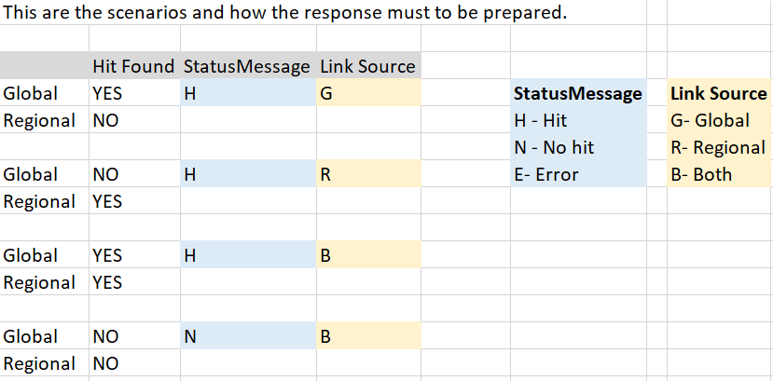

#### Audit data for report

#### Only meta / required data should have persist into the table for Audit purpose.

#### SERVICES – Error Handling

The following list defines the potential errors that a consumer of services may experience.These errors will be handled as faults by Consumers of services when flagged for fault handling.

|  |  |  |  |  |
| --- | --- | --- | --- | --- |
| **Category** | **Error Code** | **Error Source Identifier** | **Error Description** | **Action expected in the front** |
| Required Inputs Not Correct | RLE00001 | Regional | An ECONOMIC_SANCTION_RISK Service request data field is missing: No Records to Process/Screen | Fix the code and retrigger. |
| Required Inputs Not Correct | RLE00002 | Regional | One or more ECONOMIC_SANCTION_RISK Service request data fields is missing or invalid: *field names and additional information*. | Fix the code and retrigger. |
| Internal Functional Error | RLE00003 | Regional | The ECONOMIC_SANCTION_RISK Service request was unsuccessful. General Counsel has turned off all screening associated to the ESR File Search Code. | Front must wait until service has been turned on by General Counsel and retrigger again transactions |
| Informational | RLE00004 | Regional | The Economic Sanction Risk Search service has suspended screening due to business reasons. | Front must wait until service has been turned on and retrigger again transactions |
| Technical Error | RLE00005 | Regional | The ECONOMIC_SANCTION_RISK service was unable to process due to technical error. | The front must retrigger all the transactions in the queue due to the failure |
| Informational | RLE00006 | Regional | The Economic Sanction Risk Search service has suspended screening due to a system outage. | The front must retrigger all the transactions in the queue due to the failure |
| Informational | RLE00007 | Regional | The Economic Sanction Risk Search service has suspended screening due to Timeout | The front must retrigger all the transactions in the queue due to the failure |
| Unidentified Error | RLE00008 | Regional | The Economic Sanction Risk Search service was unable to process due to an unidentified error. | The front must retrigger all the transactions in the queue due to the failure |

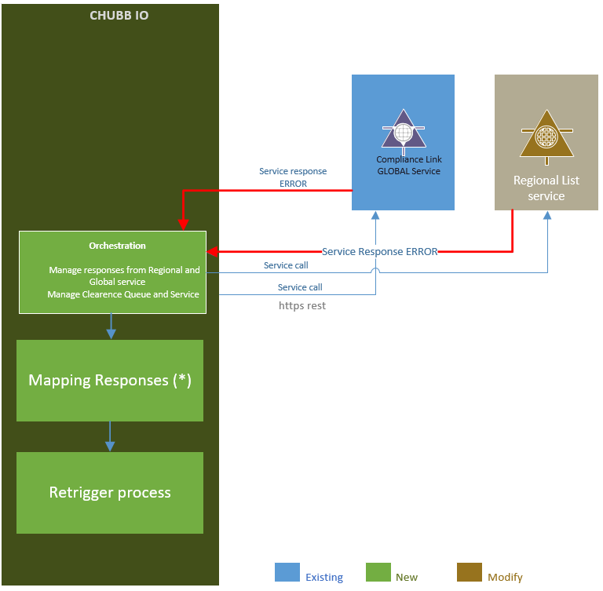

(*) Handling Error.

Only when the services (Regional/Global) respond with and TimeOut (504), Internal Server Error (500), Too many requests (429), Unathorized (401), Forbidden (403) – only Global - , in these scenarios a retry process will be available.

But when the services (Regional/Global) responses with a code such us, Payment Required (402), Unprocessable Entity (422) the system wont be able to retry because required changes on the data sent througth Integrator Service. The retry process will not be available, this error needs data correction and retry manually from front systems.

## Model Batch Process

### Logical flow

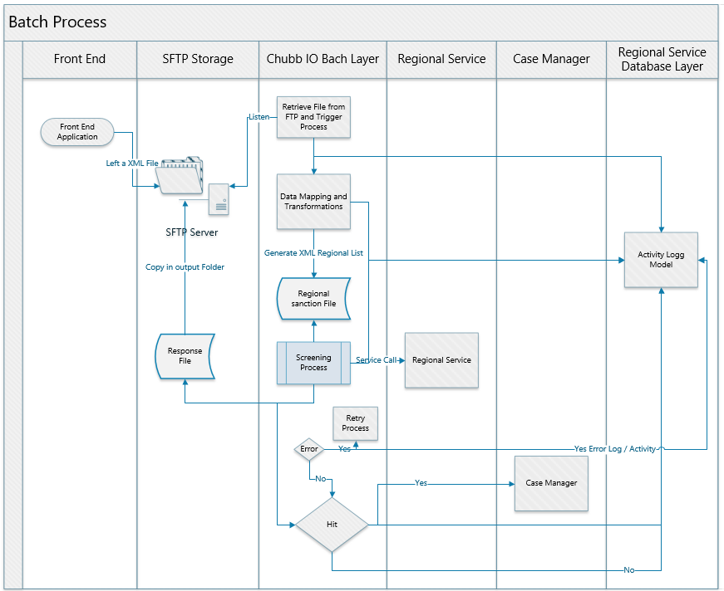

### Sequence diagram

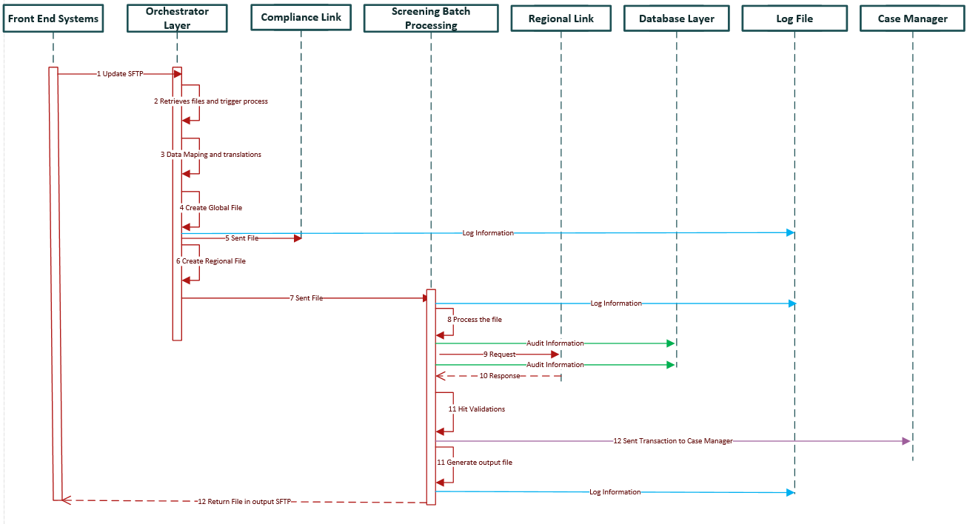

### SFTP Location

* XML File Data is located in the SFTP Server
* Name and folder structure of SFTP  
  Define name and folder structure, SFTP server and credential management for SFTP server of the input file

DEV

SIT

UAT

PROD

### Input File format (Source System)

* Data Mapping and Transformation of the XML input file to create Compliance Link and Regional files

SAMPLE FILE

### File format (Compliance link Global /Region)

SAMPLE FILE for Global & Region

XML file format

<?xml version="1.0" encoding="UTF-8" ?>

<root>

<OperationName></OperationName>

<SourceSystemKeyId></SourceSystemKeyId>

<UserId></UserId>

<SystemId></SystemId>

<SourceSystemName></SourceSystemName>

<EntryTypeCode></EntryTypeCode>

<SourceSystemTransaction></SourceSystemTransaction>

<ESRProgramName></ESRProgramName>

<ContactName></ContactName>

<ContactPhoneNumber></ContactPhoneNumber>

<BranchCode></BranchCode>

<ESRFileSearchCode></ESRFileSearchCode>

<ESRResolutionTeamName></ESRResolutionTeamName>

<SourceSystemTransactionId></SourceSystemTransactionId>

<LineOfBusiness></LineOfBusiness>

<PersonType></PersonType>

<ConsumerID></ConsumerID>

<CountryCode></CountryCode>

<TransactionType></TransactionType>

<PersonId></PersonId>

<EconomicSanctionRiskPolicyInformation>

<PolicyNumber></PolicyNumber>

<InceptionDate></InceptionDate>

<ExpirationDate></ExpirationDate>

<ControlNumber></ControlNumber>

<ExistingBusinessIndicator></ExistingBusinessIndicator>

<CertificateNumber></CertificateNumber>

<OfferingNumber></OfferingNumber>

<OfferingDB2Timestamp></OfferingDB2Timestamp>

<PolicyTypeCode></PolicyTypeCode>

<PolicyTypeSubCode></PolicyTypeSubCode>

<CustomerGroupCode></CustomerGroupCode>

<ProducingBranchNumber></ProducingBranchNumber>

<DepartmentNumber></DepartmentNumber>

<InsurerNumber></InsurerNumber>

<InsuredName></InsuredName>

<WIPInsuredNumber></WIPInsuredNumber>

<CPNumber></CPNumber>

<ProducerName></ProducerName>

<ProducerNumber></ProducerNumber>

<ProducerSubNumber></ProducerSubNumber>

<PhoneNumber></PhoneNumber>

<ESRProducerContactName></ESRProducerContactName>

</EconomicSanctionRiskPolicyInformation>

<EconomicSanctionRiskPassport>

<PassportIssueCountry></PassportIssueCountry>

<PassportNumber></PassportNumber>

</EconomicSanctionRiskPassport>

<EconomicSanctionRiskIndividual>

<SourceSystemReferenceText></SourceSystemReferenceText>

<SourceSystemSearchType></SourceSystemSearchType>

<SourceSystemSearch></SourceSystemSearch>

<ESRFileSearchCode></ESRFileSearchCode>

<ESRResolutionTeamName></ESRResolutionTeamName>

<SearchEntityValueText></SearchEntityValueText>

<IndividualFullName></IndividualFullName>

<PrefixName></PrefixName>

<GivenName></GivenName>

<MiddleInitial></MiddleInitial>

<Surname></Surname>

<NameSuffix></NameSuffix>

<IndividualBirthDate></IndividualBirthDate>

<OccupationDescription></OccupationDescription>

<EmployerName></EmployerName>

<Address>

<AddressLine1></AddressLine1>

<AddressLine2></AddressLine2>

<CityName></CityName>

<StateOrProvinceCode></StateOrProvinceCode>

<PostalCode></PostalCode>

<CountryName></CountryName>

<Driver>

<DriverLicenseNumber></DriverLicenseNumber>

<DriverPostalState></DriverPostalState>

<Abbreviation></Abbreviation>

<DriverLicenseCountryCode></DriverLicenseCountryCode>

<DriverLicensedDate></DriverLicensedDate>

<DriverLicenseCopyIndicator></DriverLicenseCopyIndicator>

</Driver>

</Address>

</EconomicSanctionRiskIndividual>

<EconomicSanctionRiskOrganization>

<SourceSystemReferenceText></SourceSystemReferenceText>

<SourceSystemSearchType></SourceSystemSearchType>

<TypeDescription></TypeDescription>

<SourceSystemSearch></SourceSystemSearch>

<ESRFileSearchCode></ESRFileSearchCode>

<ESRResolutionTeamName></ESRResolutionTeamName>

<SearchEntityValueText></SearchEntityValueText>

<ESROrgName></ESROrgName>

<OrgIncDate></OrgIncDate>

<OrgTypeDescription></OrgTypeDescription>

<OrgIncStateOrProvinceCode></OrgIncStateOrProvinceCode>

<OrgTaxIdNumber></OrgTaxIdNumber>

<Address>

<AddressLine1></AddressLine1>

<AddressLine2></AddressLine2>

<CityName></CityName>

<StateOrProvinceCode></StateOrProvinceCode>

<PostalCode></PostalCode>

<CountryName></CountryName>

</Address>

</EconomicSanctionRiskOrganization>

<EconomicSanctionRiskVessel>

<SourceSystemReferenceText></SourceSystemReferenceText>

<SourceSystemSearchType></SourceSystemSearchType>

<SourceSystemSearch></SourceSystemSearch>

<ESRFileSearchCode></ESRFileSearchCode>

<ESRResolutionTeamName></ESRResolutionTeamName>

<SearchEntityValueText></SearchEntityValueText>

<ESRVesselName></ESRVesselName>

<VesselTypeCode></VesselTypeCode>

<VesselGrossWeight></VesselGrossWeight>

<VesselDeadWeight></VesselDeadWeight>

<VesselountryCode></VesselountryCode>

<Address>

<AddressLine1></AddressLine1>

<AddressLine2></AddressLine2>

<CityName></CityName>

<StateOrProvinceCode></StateOrProvinceCode>

<PostalCode></PostalCode>

<CountryName></CountryName>

</Address>

</EconomicSanctionRiskVessel>

<EconomicSanctionRiskLocation>

<SourceSystemReferenceText></SourceSystemReferenceText>

<SourceSystemSearchType></SourceSystemSearchType>

<SourceSystemSearch></SourceSystemSearch>

<ESRFileSearchCode></ESRFileSearchCode>

<ESRResolutionTeamName></ESRResolutionTeamName>

<SearchEntityValueText></SearchEntityValueText>

<ESRLocationName></ESRLocationName>

<Address>

<AddressLine1></AddressLine1>

<AddressLine2></AddressLine2>

<CityName></CityName>

<StateOrProvinceCode></StateOrProvinceCode>

<PostalCode></PostalCode>

<CountryName></CountryName>

</Address>

</EconomicSanctionRiskLocation>

<EconomicSanctionRiskClaimInformation>

<ClaimOccurrenceNumber></ClaimOccurrenceNumber>

<ClaimNumber></ClaimNumber>

<ClaimLineFeatureNumber></ClaimLineFeatureNumber>

<ClaimAdjusterUserId></ClaimAdjusterUserId>

<ClaimAdjusterName></ClaimAdjusterName>

<ClaimantName></ClaimantName>

<FirstNoticeOfLossBranch></FirstNoticeOfLossBranch>

<BranchNumber></BranchNumber>

</EconomicSanctionRiskClaimInformation>

<EconomicSanctionRiskPaymentInformation>

<PaymentRemittanceNumber></PaymentRemittanceNumber>

<PaymentAmount>0</PaymentAmount>

<PaymentPriorityCode></PaymentPriorityCode>

<PaymentMethodDescription></PaymentMethodDescription>

<ESRTransactionStatusDescription></ESRTransactionStatusDescription>

</EconomicSanctionRiskPaymentInformation>

</root>

### Output file format (to source system)

* XML file format

<?xml version="1.0" encoding="UTF-8" ?>

<root>

    <SystemId/>

    <StatusCode/>

    <SourceSystemKeyId/>

    <Code/>

    <StatusMessage/>

    <LinkSource/>

    <Error>

        <ErrorDescription/>

        <ErrorSeverityLevel/>

    </Error>

</root>

## Model Clearance Process

### Sequence diagram (Global)

Yet to get the details ; Existing service call

### Sequence diagram (Region)

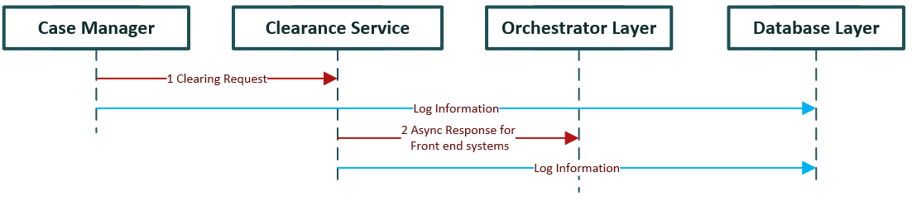

* **Interface for** **Clearance process**. This is the request and response of clearance service. This Clearance process Case Manager calls it.

Request:

{

"SystemId": "",

"SourceSystemKeyId": "",  
 "Code": "",

  "StatusMessage": "",

  "Error":{

    "ErrorDescription": "",

    "ErrorSeverityLevel":""

  }

}

| **Element Name** | **Description** |
| --- | --- |
|  |
| SystemId | The SystemId represents a Chubb Source System Id. Always Populated. |
| SourceSystemKeyId | Respresent the transaction – Always populated |
| Code | Http response code Always populated |
| StatusMessage | Message of the validation  H - Hit N - No Hit  Always Populated |
| Error | Only be filled when an error ocurs - Conditional to error ocurs. |
| ErrorCode | Https Response code |
| ErrorDescription | Description of the error |
| ErrorSeverityLevel | E = Error  I = Information  W = Warning |

Response:

{  
 "Code": "",

  "Error":{

    "ErrorDescription": "",

    "ErrorSeverityLevel":""

  }

}

| **Element Name** | **Description** |
| --- | --- |
|  |
| Code | Http response code Always populated |
| Error | Only be filled when an error ocurs - Conditional to error ocurs. |
| ErrorCode | Https Response code |
| ErrorDescription | Description of the error |
| ErrorSeverityLevel | E = Error  I = Information  W = Warning |

## Utility features

Following are the common features are being implemented in the above compliance services

### Audit

### Error / Exception Log

# Implementation - Case Manager:

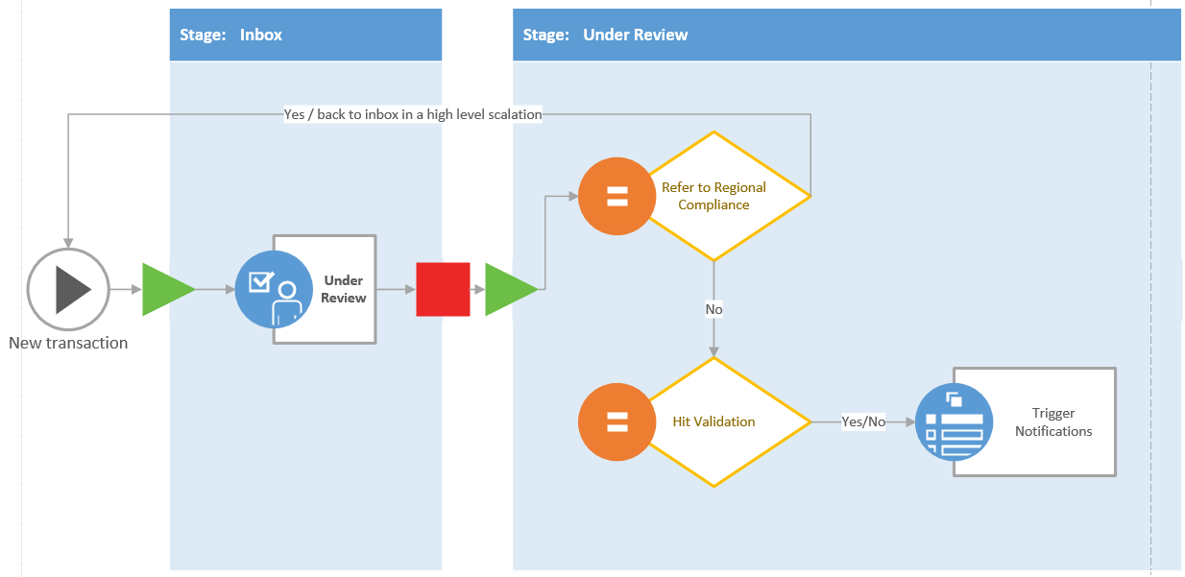

|  |  |
| --- | --- |
| **New** | New transaction |
| **under review** | Status that indicase the compliance officer have started to check the case. There should a date that reflect when each phase in the workflow was started.  User should not be able to return from this status to “New” |
| **Refer to regional compliance** | This status must follow “under review status” and this will refleject a referral activity /escalation to a superior roll. |
| **False postive** | **Not hit found- This status is when the compliance officer have complete the evaluation. After this status the transaction should be in read only.** |
| **True match** | **Hit found- - This status is when the compliance officer have complete the evaluation. After this status the transaction should be in read only.** |
| **Warning confirmed** | N/A **This status is when the compliance officer have complete the evaluation. After this status the transaction should be in read only.** |
| **Warning discarted** | N/A **This status is when the compliance officer have complete the evaluation. After this status the transaction should be in read only.** |

3B) Class Diagrams:

Validations are part of Integrator Services; also, this diagram will be used by Case Manager validator for CRUD (Create, Read, Update, Delete) operations.

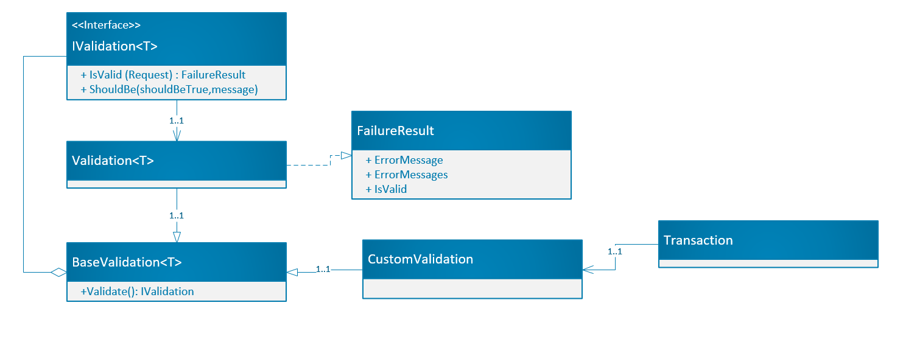

Integrator service

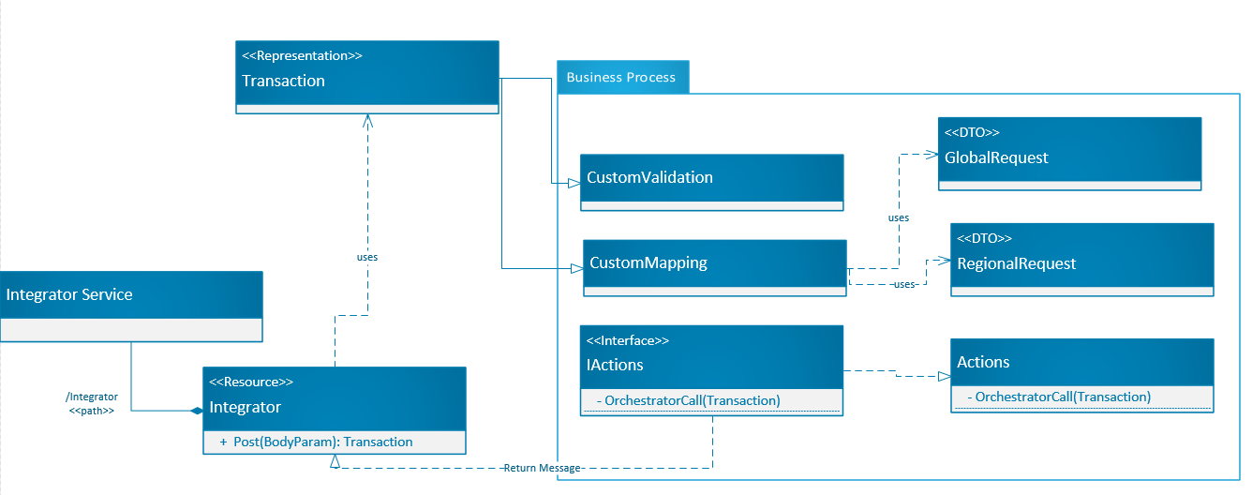

**3C) Class Changes / Program Specs:** For new development, if using Javadoc or other means of capturing as comments in-line with code, provide link, otherwise complete the table for each class that requires changes.

## Sequence Diagrams:

The activity logger (audit), will saved in to the database each step performed (even the errors occurred) in every Request and Response from a service in order to get the complete trace for each transaction.

The logger will function as a normal application log, using three levels, Error, warning, debug.

On Line Screening

**JSON for Integrator Service**  
Create JSON/WSDL for the Integration Service, with all the data necessary to call both Compliance Link and Regional Service

- Dummy Integrator service  
Create dummy service instance in order to provide wsdl to consumer systems and also for testing purposes

- Define data validations for incoming data  
Identify all the validations to be performed on the information received on the Integration service request, for mandatory and optative data.  
It includes data integrity and business logic

- Integration Validation Service Layer  
Create a layer to perform validation, based on previous definition

- Define error messages  
Define standard error message that will be sent on Integration Service response in case of invalid information

- Mapping Layer  
Create a Mapping layer to perform data mapping of integration service with both Compliance Link and Regional Service.

Case Manager

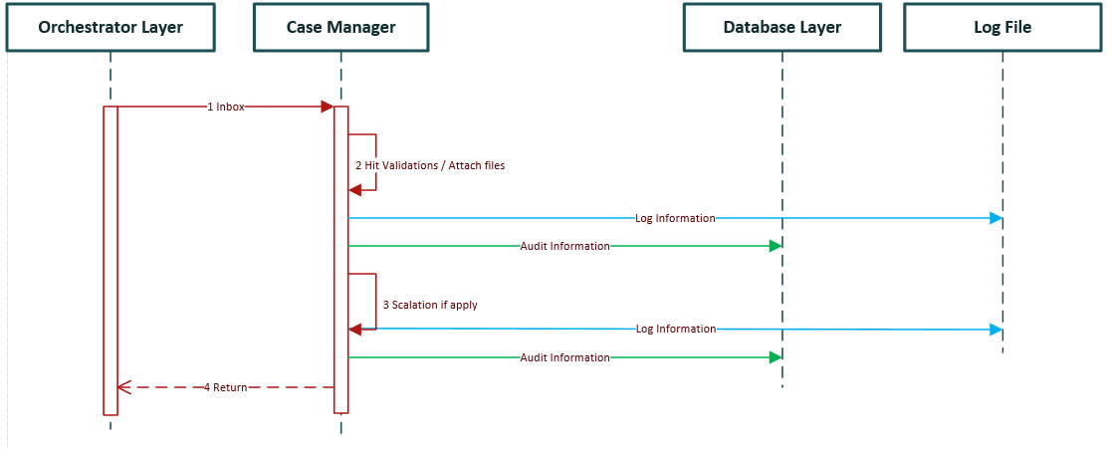

**Data Model**

* Data model for Case Manager  
  Create data model for case manager, workflow and administration

**Case Manager Frontend**

* Search Screen for Clearance  
  Frontend and backend components to perform records pending of clearance, to lookup by Name, Id Type, Id Number, Hit Type.
* Clearance process  
  Frontend and backend components to perform clearance of persons based on the result of a search.
* Clearance status & history  
  Lookup and Display clearance status and history
* Search log data (Service request & response)  
  Lookup for log data of service request and responses.
* Display Audit information  
  Display audit information based on the search

**Clearance Workflow**

* Workflow clearance escalation  
  Component frontend and backend to manage clearance escalation workflow

**Administration**

* Workflow Level configuration  
  Components frontend and backend to administrate workflow levels
* User Maintenance  
  Components frontend and backend for user maintenance

**Inventory of Reusable Routines:** Describe all reusable routines that are common across the solution and are to be used to facilitate development (e.g. utility classes).

## **Error Handling and Logging Design:**

**3F1) Error Handling Implementation:** Describe how error handling is to be implemented. Include class diagrams for exception handling and details about error messages including format and content of messages.

**Logging Implementation:** Describe how logging is to be implemented. Include specifics such as where to insert logging, definitions of logging levels, and logging message formats Include any standards that should be utilized (e.g. JUL) and how to implement. Please see example logging standard and project example for details

## Design Patterns (System Interaction Flowchart)

### Figure 1: Example implementation of Model View Presenter pattern for ASP.Net

## Policy Document Generation

## Interface to Back Office System

## Template Management

## Rendering Service

## Document Storage and Retrieval

### Http Servlet

### StoreDoc

### RetrieveDoc

### Messages

### Message 1

### Message 2

### Services

### Service 1

### Service 2

## New System Interfaces

* Unique entry point **JSON for integrator** will sent by Chubb

The proposal is to have an entity to request with all data required to create the request to Compliance Link and Regional Service, previous perform validations and mappings.

The JSON proposal:

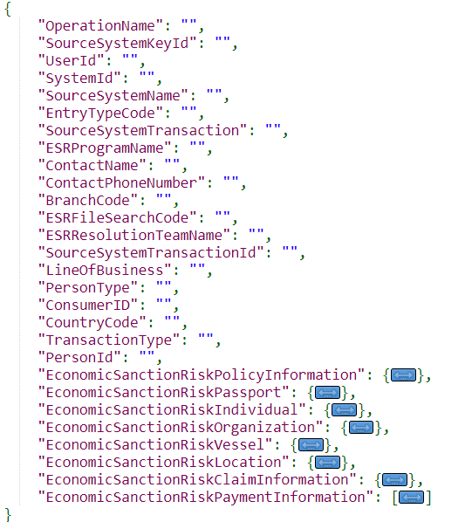

Exclusive fields for Passport.

Exclusive fields for Vessel.

Exclusive fields for Organization.

Exclusive fields for Individual.

Exclusive fields for Claim.

Exclusive fields for Location.

Common fields

### 

Exclusive fields for Payment.

### Operations Inputs

| **Element Name** | **Required?** | **Format** |
| --- | --- | --- |
|  |  |
| OperationName | R | Character |
| SourceSystemKeyId | R | Character |
| UserId | R | Character |
| SystemId | C | Character |
| SourceSystemName | C | Character |
| EntryTypeCode | C | Character |
| SourceSystemTransaction | O | Character |
| ESRProgramName | R | Character |
| ContactName | O | Character |
| ContactPhoneNumber | O | Character |
| BranchCode | R | Character |
| ESRFileSearchCode | C | Character |
| ESRResolutionTeamName | C | Character |
| SourceSystemTransactionId | O | Character |
| LineOfBusiness | R | Integer |
| PersonType | R | Integer |
| ConsumerID | R | String(2) |
| CountryCode | R | Integer |
| TransactionType | R | Integer |
| PersonId | O | Integer |
| OperationName |  |  |
| SourceSystemKeyId | O | Character |
| UserId | O | Date |
| SystemId | O | Date |
| SourceSystemName | O | Character |
| EntryTypeCode | O | Character |
| SourceSystemTransaction TypeName | O | Character |
| ESRProgramName | O | Character |
| ContactName | O | Character |
| ContactPhoneNumber | O | Character |
| BranchCode | O | Character |
| ESRFileSearchCode | O | Character |
| ESRResolutionTeamName | O | Character |
| SourceSystemTransactionId | O | Character |
| LineOfBusiness | O | Character |
| PersonType | O | Character |
| ConsumerID | O | Character |
| CountryCode | O | Character |
| TransactionType | O | Character |
| PersonId | O | Character |
| ProducerSubNumber | O | Character |
| PhoneNumber | O | Character |
| ESRProducerContactName | O | Character |
| ***EconomicSanctionRiskPassport*** |  |  |
| PassportIssueCountry | O | Character |
| PassportNumber | O | Character |
| ***EconomicSanctionRiskIndividual*** |  |  |
| SourceSystemReferenceText | C | Character |
| SourceSystemSearchType - Description | O | Character |
| SourceSystemSearch - Identifier | O | Character |
| ESRRoleTypeCode [ ] | C | Character |
| ESRFileSearchCode | C | Character |
| ESRResolutionTeamName | C | Character |
| SearchEntityValueText | C | Character |
| IndividualFullName | C | Character |
| PrefixName | O | Character |
| GivenName | C | Character |
| MiddleInitial | O | Character |
| Surname | C | Character |
| NameSuffix | O | Character |
| IndividualBirthDate | O | Date |
| OccupationDescription | O | Character |
| EmployerName | O | Character |
| **Address/** |  |  |
| AddressLine1 | O | Character |
| AddressLine2 | O | Character |
| CityName | O | Character |
| StateOrProvinceCode | O | Character |
| PostalCode | O | Character |
| CountryName | O | Character |
| **Driver (Not used in ClaimPayment Request)** |  |  |
| DriverLicenseNumber | O | Character |
| DriverPostalState | O | Character |
| Abbreviation |  |  |
| DriverLicenseCountryCode | O | Character |
| DriverLicensedDate |  | Date |
| DriverLicenseCopyIndicator | O | Character |
| ***EconomicSanctionRiskOrganization*** |  |  |
| SourceSystemReferenceText | C | Character |
| SourceSystemSearchType - Description | O | Character |
| TypeDescription |  |  |
| SourceSystemSearch - Identifier | O | Character |
| ESRRoleTypeCode [] | C | Character |
| ESRFileSearchCode | O | Character |
| ESRResolutionTeamName | O | Character |
| SearchEntityValueText | C | Character |
| ESROrgName | C | Character |
| OrgIncDate | O | Date |
| OrgTypeDescription | O | Character |
| OrgIncStateOrProvinceCode | O | Character |
| OrgTaxIdNumber | O | Character |
| Address |  |  |
| AddressLine1 | O | Character |
| AddressLine2 | O | Character |
| CityName | O | Character |
| StateOrProvinceCode | O | Character |
| PostalCode | O | Character |
| CountryName | O | Character |
| ***EconomicSanctionRiskPassport*** |  |  |
| PassportIssueCountry |  |  |
| PassportNumber |  |  |
| ***EconomicSanctionRiskVessel*** |  |  |
| SourceSystemReferenceText | C | Character |
| SourceSystemSearchType - Description | O | Character |
| SourceSystemSearch - Identifier | O | Character |
| ESRRoleTypeCode [ ] | C | Character |
| ESRFileSearchCode | C | Character |
| ESRResolutionTeamName | C | Character |
| SearchEntityValueText | C | Character |
| ESRVesselName | C | Character |
| VesselTypeCode | O | Character |
| VesselGrossWeight | O | Character |
| VesselDeadWeight | O | Character |
| VesselCountryCode | O | Character |
| **Address** |  |  |
| AddressLine1 | O | Character |
| AddressLine2 | O | Character |
| CityName | O | Character |
| StateOrProvinceCode | O | Character |
| PostalCode | O | Character |
| CountryName | O | Character |
| ***EconomicSanctionRiskLocation*** |  |  |
| SourceSystemReferenceText | C | Character |
| SourceSystemSearchType - Description | O | Character |
| SourceSystemSearch - Identifier | O | Character |
| ESRRoleTypeCode [] | C | Character |
| ESRFileSearchCode | C | Character |
| ESRResolutionTeamName | C | Character |
| SearchEntityValueText | C | Character |
| ESRLocationName | C | Character |
| **Address** |  |  |
| AddressLine1 | O | Character |
| AddressLine2 | O | Character |
| CityName | O | Character |
| StateOrProvinceCode | O | Character |
| PostalCode | O | Character |
| CountryName | O | Character |
| ***EconomicSanctionRiskClaimInformation*** |  |  |
| ClaimOccurrenceNumber | O | Character |
| ClaimNumber | O | Character |
| ClaimLineFeatureNumber | O | Character |
| ClaimAdjusterUserId | O | Character |
| ClaimAdjusterName | O | Character |
| ClaimantName | O | Character |
| **FirstNoticeOfLossBranch** |  |  |
| BranchNumber | O | Character |
| ***EconomicSanctionRiskPaymentInformation*** |  |  |
| PaymentRemittanceNumber | O | Character |
| PaymentAmount | O | Decimal |
| PaymentPriorityCode | O | Character |
| PaymentMethodDescription | O | Character |
| ESRTransactionStatusDescription | O | Character |

Validations.

This validation will performed every time when a request is performed. Returning error if one of them fails.

| **Element Name** | **Return value on validations Fails** |
| --- | --- |
|  |
| OperationName | String is null or empty |
| SourceSystemKeyId | String is null or empty |
| UserId | String is null or empty |
| ESRProgramName | String is null or empty |
| LineOfBusiness | Is null |
| PersonID | String is null or empty |
| PersonType | Is null |
| ConsumerID | Is null |
| CountryCode | String is null or empty |
| TransactionType | Is null |
| BranchCode | String is null or empty |
| ESRFileSearchCode | String is null or empty |
| ESRResolutionTeamName | String is null or empty |

OperationName, is the key field in order to identify which operation we need to call for Global CL.

The Values for this field are: *CLPolicy, CLCLaim, CLClaimPayment*. If recibe the value ***CLClearanceNotification*** we return an error 405 Method not allowed.

This operation name **is part of the URL** of Global CL, that we have to invoque (***OperationName*** field) example:

[https://nasit.chubbdigital.com/servicing.es-screening/***CLClaim***](https://nasit.chubbdigital.com/servicing.es-screening/CLClaim)  
[http://nasit.chubbdigital.com/enterprise.servicing.economicsanctions/***CLPolicy***](http://nasit.chubbdigital.com/enterprise.servicing.economicsanctions/CLPolicy)  
[https://nasit.chubbdigital.com/servicing.es-screening/***CLClaimPayment***](https://nasit.chubbdigital.com/servicing.es-screening/CLClaimPayment)

Mappings

This mapping indicate how the request of Sanction list will be mapped

|  |  |
| --- | --- |
| Field in Request | Map Regional Link as |
| CountryID | Will be mapped using the reference table Countries searching the proper value in reference country table  the input field to use: CountryCode |
| PersonName | SourceSystemReferenceText,  use the same value of  IndividualFullName field |
| TransactionIdentifier | Mapping against  SourceSystemKeyId |

This section describe where each section will be used:

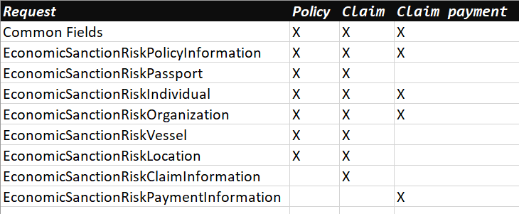

The mappings for CountryID fields – A new field needs to be created on the table (CountryID). We receive the code and search in this table in order to return the value of “CountryID”

Table example – cropped.

|  |  |  |  |
| --- | --- | --- | --- |
| Code | Country Name | Country Abbreviation | CountryID |
| *AA* | *ALBANIA* | *ALBA* | *0001* |
| *AD* | *ANDORRA* | *ANDO* | *…* |
| *AF* | *AFGHANISTAN* | *AFGH* | *…* |
| *AG* | *ANTIGUA AND BARBUDA* | *TGUA* | *….* |
| *AI* | *DJIBOUTI* | *DJIB* | *…* |
| *AM* | *ARMENIA* | *ARME* | *…* |
| *AO* | *ANGOLA* | *ANGO* | *…* |
| *AQ* | *ANTARCTICA* | *ANTA* | *….* |
| *AW* | *ARUBA* | *ARUB* | *0009* |
| *AX* | *ALAND ISLANDS* | *ALAI* |  |
| *BA* | *BOSNIA* | *BOSN* |  |
| *BD* | *BANGLADESH* | *BANG* |  |

- Mapping Layer  
Create a Mapping layer to perform data mapping of integration service with both Compliance Link and Regional Service.

- Caller for Compliance Link Service  
Component to call Compliance Link service based on the mapping made by the Mapping Layer

- Caller for Regional Service  
Component to call Regional service based on the mapping made by the Mapping Layer

- Data mapping and Transformation

JSON Complete Example

{

"OperationName": "",

"SourceSystemKeyId": "",

"UserId": "",

"SystemId": "",

"SourceSystemName": "",

"EntryTypeCode": "",

"SourceSystemTransaction": "",

"ESRProgramName": "",

"ContactName": "",

"ContactPhoneNumber": "",

"BranchCode": "",

"ESRFileSearchCode": "",

"ESRResolutionTeamName": "",

"SourceSystemTransactionId": "",

"LineOfBusiness": "",

"PersonType": "",

"ConsumerID": "",

"CountryCode": "",

"TransactionType": "",

"PersonId": "",

"EconomicSanctionRiskPolicyInformation": {

"PolicyNumber": "",

"InceptionDate": "",

"ExpirationDate": "",

"ControlNumber": "",

"ExistingBusinessIndicator": "",

"CertificateNumber": "",

"OfferingNumber": "",

"OfferingDB2Timestamp": "",

"PolicyTypeCode": "",

"PolicyTypeSubCode": "",

"CustomerGroupCode": "",

"ProducingBranchNumber": "",

"DepartmentNumber": "",

"InsurerNumber": "",

"InsuredName": "",

"WIPInsuredNumber": "",

"CPNumber": "",

"ProducerName": "",

"ProducerNumber": "",

"ProducerSubNumber": "",

"PhoneNumber": "",

"ESRProducerContactName": ""

},

"EconomicSanctionRiskPassport": {

"PassportIssueCountry": "",

"PassportNumber": ""

},

"EconomicSanctionRiskIndividual": {

"SourceSystemReferenceText": "",

"SourceSystemSearchType": "",

"SourceSystemSearch": "",

"ESRRoleTypeCode": [],

"ESRFileSearchCode": "",

"ESRResolutionTeamName": "",

"SearchEntityValueText": "",

"IndividualFullName": "",

"PrefixName": "",

"GivenName": "",

"MiddleInitial": "",

"Surname": "",

"NameSuffix": "",

"IndividualBirthDate": "",

"OccupationDescription": "",

"EmployerName": "",

"Address": {

"AddressLine1": "",

"AddressLine2": "",

"CityName": "",

"StateOrProvinceCode": "",

"PostalCode": "",

"CountryName": "",

"Driver": {

"DriverLicenseNumber": "",

"DriverPostalStateAbbreviation": "",

"DriverLicenseCountryCode": "",

"DriverLicensedDate": "",

"DriverLicenseCopyIndicator": ""

}

}

},

"EconomicSanctionRiskOrganization": {

"SourceSystemReferenceText": "",

"SourceSystemSearchType": "",

"TypeDescription": "",

"SourceSystemSearch": "",

"ESRRoleTypeCode": [],

"ESRFileSearchCode": "",

"ESRResolutionTeamName": "",

"SearchEntityValueText": "",

"ESROrgName": "",

"OrgIncDate": "",

"OrgTypeDescription": "",

"OrgIncStateOrProvinceCode": "",

"OrgTaxIdNumber": "",

"Address": {

"AddressLine1": "",

"AddressLine2": "",

"CityName": "",

"StateOrProvinceCode": "",

"PostalCode": "",

"CountryName": ""

}

},

"EconomicSanctionRiskVessel": {

"SourceSystemReferenceText": "",

"SourceSystemSearchType": "",

"SourceSystemSearch": "",

"ESRRoleTypeCode": [],

"ESRFileSearchCode": "",

"ESRResolutionTeamName": "",

"SearchEntityValueText": "",

"ESRVesselName": "",

"VesselTypeCode": "",

"VesselGrossWeight": "",

"VesselDeadWeight": "",

"VesselountryCode": "",

"Address": {

"AddressLine1": "",

"AddressLine2": "",

"CityName": "",

"StateOrProvinceCode": "",

"PostalCode": "",

"CountryName": ""

}

},

"EconomicSanctionRiskLocation": {

"SourceSystemReferenceText": "",

"SourceSystemSearchType": "",

"SourceSystemSearch": "",

"ESRRoleTypeCode": [],

"ESRFileSearchCode": "",

"ESRResolutionTeamName": "",

"SearchEntityValueText": "",

"ESRLocationName": "",

"Address": {

"AddressLine1": "",

"AddressLine2": "",

"CityName": "",

"StateOrProvinceCode": "",

"PostalCode": "",

"CountryName": ""

}

},

"EconomicSanctionRiskClaimInformation": {

"ClaimOccurrenceNumber": "",

"ClaimNumber": "",

"ClaimLineFeatureNumber": "",

"ClaimAdjusterUserId": "",

"ClaimAdjusterName": "",

"ClaimantName": "",

"FirstNoticeOfLossBranch": "",

"BranchNumber": ""

},

"EconomicSanctionRiskPaymentInformation": [

{

"PaymentRemittanceNumber": "",

"PaymentAmount": 0,

"PaymentPriorityCode": "",

"PaymentMethodDescription": "",

"ESRTransactionStatusDescription": ""

}

]

}

Output Response Message

{

"SystemId": "",

  "StatusCode": "",

"SourceSystemKeyId": "",  
"Code": "",

  "StatusMessage": "",  
 "LinkSource": "",

  "Error":{

    "ErrorDescription": "",

    "ErrorSeverityLevel":""

  }

}

| **Element Name** | **Description** |
| --- | --- |
|  |
| SystemId | The SystemId represents a Chubb Source System Id. Always Populated. |
| StatusCode | Always populated. **S** = Successful (Screening completed)  **E** = Error (One or more entities encountered an error). |
| SourceSystemKeyId | Respresent the transaction – Always populated |
| Code | Http response code Always populated |
| StatusMessage | Message of the validation  **H** - Hit **N** - No Hit  **E** – Error  Always Populated |
| LinkSource | Link validation **G** - Global **R** - Regional  **B** – Both Always Populated |
| Error | Only be filled when an error ocurs - Conditional to error ocurs. |
| ErrorCode | Https Response code |
| ErrorDescription | Description of the error |
| ErrorSeverityLevel | **E** = Error  **I** = Information  **W** = Warning |

## Changed/Deleted System Interfaces

# Physical Deployment

## Policy Document Generation

### Referencing

### Deployment Details

### Clustering

## Lookup Services

## Process Coordination

## Interface Back Office Systems

## Template Management

## Rendering Service

## Document Storage and Retrieval

## Security

# Non-Functional Design Considerations

## Performance

### Memory

### I/O

### Cacheing

### Stored Procedures

### Use

### Instantiation

### Transaction Throughput and Response Times

## Resilience

## Reliability

## Scalability

## Data Backup

All backups will be part of standar operation:

* Databases
* Web application serves

## System Healthcheck Considerations

# Database Design

## Data Dictionary

## Managed Document

### Doc Version

A document which is managed by the application

|  |  |  |  |  |  |  |
| --- | --- | --- | --- | --- | --- | --- |
| **Column Name** | **PK** | **FK** | **Default** | **Nullable** | **Data Type** | **Max Length** |
| DocID | Yes | Yes | NULL | No | Int |  |
| Country |  | Yes | NULL | No | varchar | 2 |
| DocName |  | Yes | NULL | No | Varchar | 150 |
| IsSysDoc |  |  | N | No | Char |  |
| LastUpdate |  |  | NULL | No | Datetime |  |
| LastUpdatedBy |  | FK | NULL | No | Int |  |
| DateSeqNum |  | FK | NULL | No | Int |  |

### Nested Version

A nested version

|  |  |  |  |  |  |  |
| --- | --- | --- | --- | --- | --- | --- |
| **Column Name** | **PK** | **FK** | **Default** | **Nullable** | **Data Type** | **Max Length** |
| NestedVersion | Yes | Yes | NULL | No | Int |  |
| Version | Yes | Yes | NULL | No | Int |  |
| DocID | Yes | Yes | NULL | No | Int |  |
| NestedDocID | Yes | Yes | NULL | No | Int |  |
| SortOrder |  |  | NULL | No | Int |  |
| LastUpdate |  |  | NULL | No | Datetime |  |
| LastUpdatedBy |  | Yes | NULL | No | Int |  |

### Data Content

A version of a document

|  |  |  |  |  |  |  |
| --- | --- | --- | --- | --- | --- | --- |
| **Column Name** | **FK** | **PK** | **Default** | **Nullable** | **Data Type** | **Max Length** |
| DocID | Yes | Yes | NULL | No | Int |  |
| Version | Yes | Yes | NULL | No | Int |  |
| Language | Yes | Yes | NULL | No | Int |  |
| Format | Yes | Yes | NULL | No | Int |  |
| LastUpdate |  |  | NULL | No | Datetime |  |
| BinaryData |  |  | NULL | No | BLOB | 1000000000 |
| LastUpdatedBy |  | Yes | NULL | No | Int |  |

### Format

Format of a document

|  |  |  |  |  |  |  |
| --- | --- | --- | --- | --- | --- | --- |
| **Column Name** | **PF** | **FK** | **Default** | **Nullable** | **Data Type** | **Max Length** |
| Format | Yes | Yes | NULL | No | Int |  |
| MIME_Type |  |  | NULL | No | Varchar | 100 |
| Extension |  |  | NULL | No | Varchar | 20 |

## Entity Relationship Diagram

There is a table call SanctionLog with a relation with SanctionLogsDetails, we can use those tables, this will be validated after the access arrived from chubb. This is our proposal for the database squema.

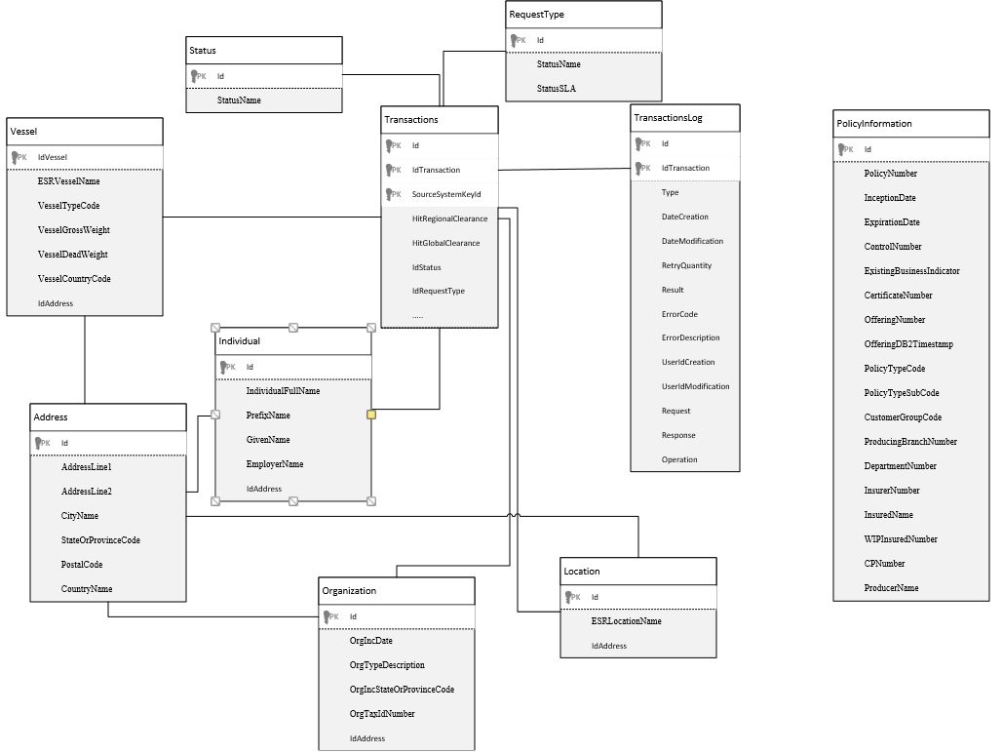

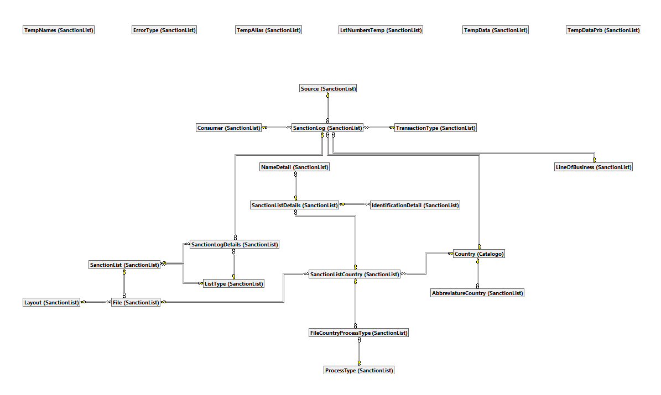

## Database Design Considerations

### Database Files – New/Changed/Deleted

### Impacted Files

| Ref. | File Name | Description | N/C/D | Owner | S/F/J/D | Folder Path |
| --- | --- | --- | --- | --- | --- | --- |
|  |  |  |  |  |  |  |
|  |  |  |  |  |  |  |

### Impacted File Details

# User Interface

## Screen Mock-ups

Case Manager

**User Interface**

Login

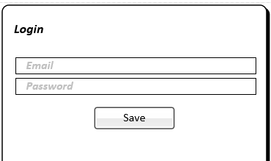

Home



Inbox



Search



Match Search Results



Match Review



**IT Support**

Resolution Teams Configuration

Main View

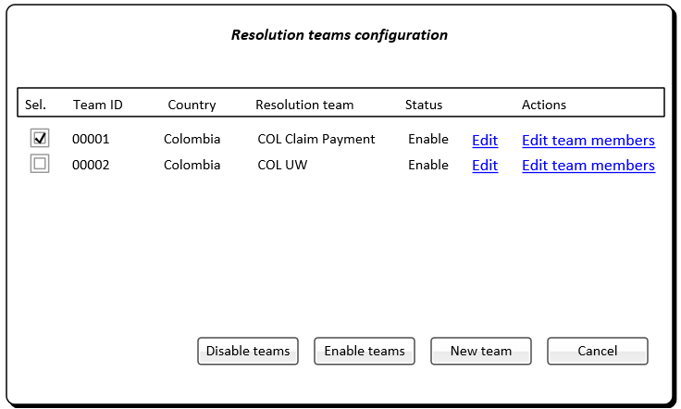

New view

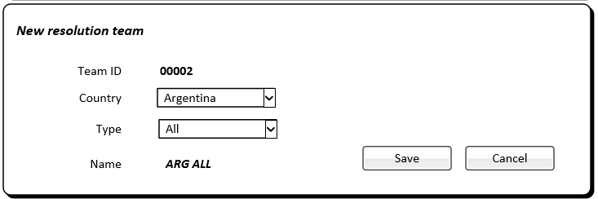

***TeamID****: will be calculated by application automatically*

***Type****: values, All Transactions, UW, Claims, Claim Payments, Support, Administrator*

***Name****: calculated automatically, County+Type*

Edit view

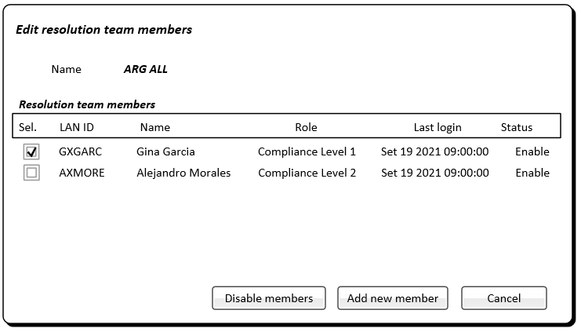

Add new Resolution team, member view

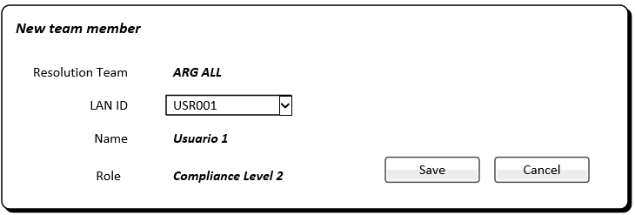

***Lan ID****: Users dropdown List*

User Manager View

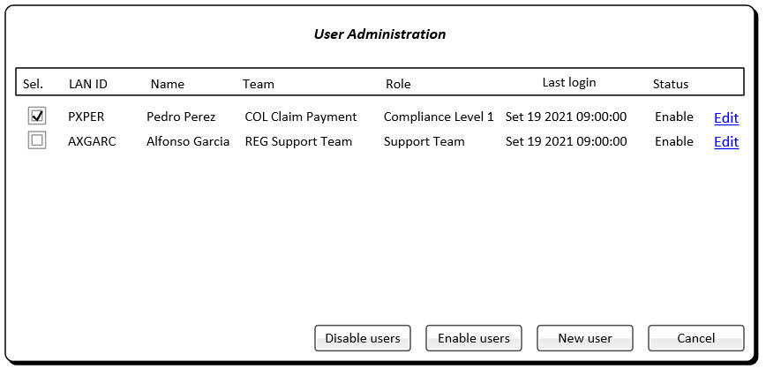

New user view

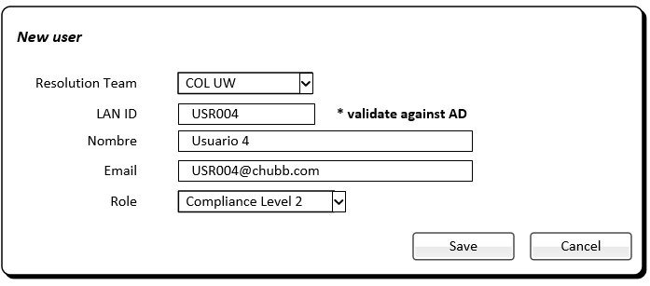

***Role****: Compliance Level 1, Compliance Level 2, Compliance Level 3, Support team, Administrator.*

Edit user view

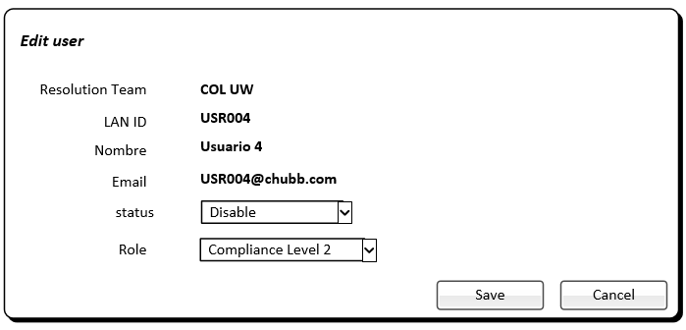

Batch process management – Main view

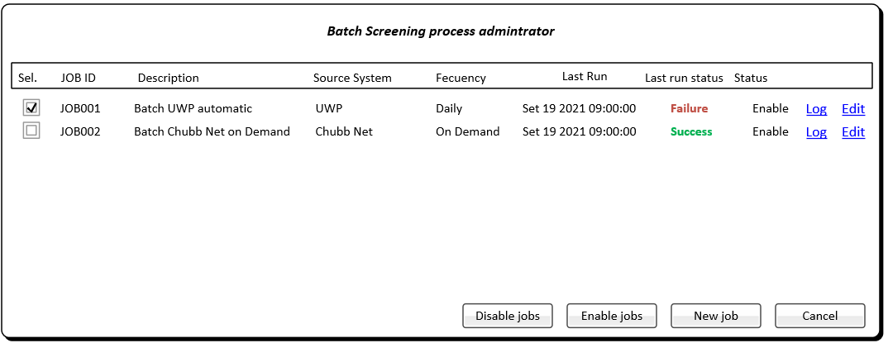

Add Job

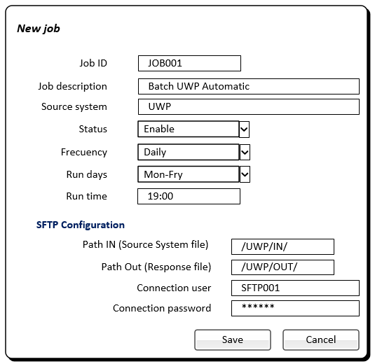

***Status****: Disable, Enable*

**Frecuency**: Daily, On demand, Weekly

**Run days**: Mon-Fri (Monday to Friday), Every Day, Monday, Tuesday…Friday

Edit Job

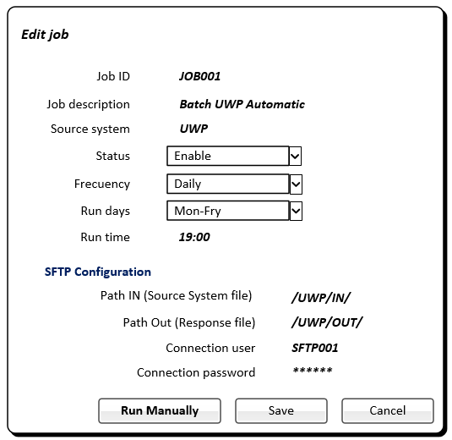

Process log detail view

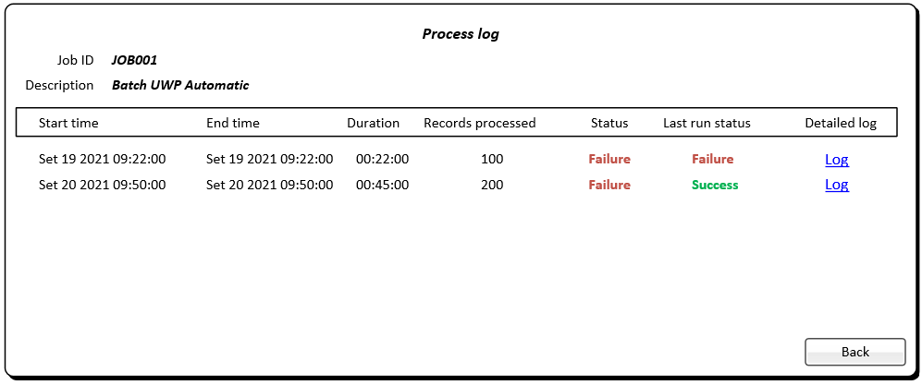

Transaction view – Main

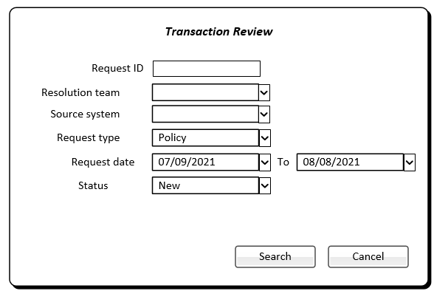

***Status****: New, Under review, Refer to Level 2, Refer to Regional, Compliance, False positive, True match, Warning confirmed, Warning discarted, Error.*

***Request Type****: Policy, Claim, Claim payment.*

Search Result view

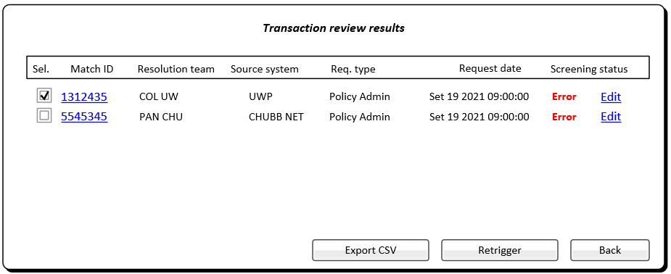

Edit View



Alerts and Notifications – Main view

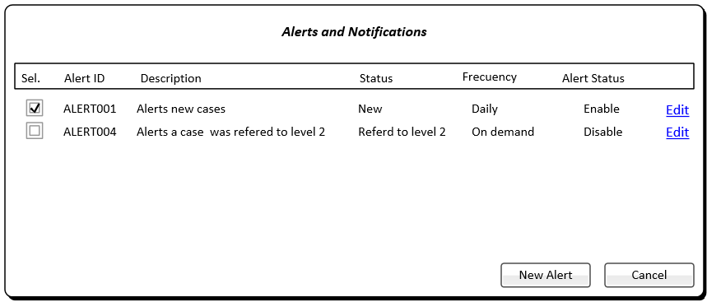

Edit View

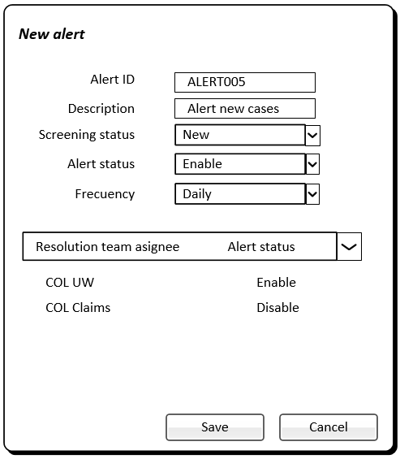

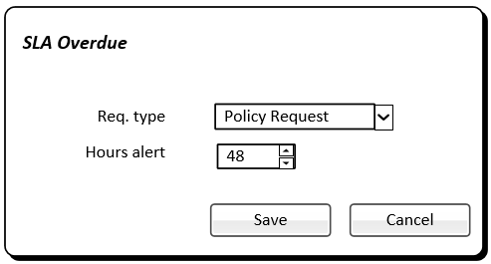



## 7.2 Impacted User Interface/Screens

| Ref. | User Interface/Screen Name | Description | N/C/D | Owner | Folder Path |
| --- | --- | --- | --- | --- | --- |
|  |  |  |  |  |  |
|  |  |  |  |  |  |

## 7.3 User Interface/Screen Details

The expected folders are:

* **Batch:** This folder should allocate all the batch process arriving from the countries.
* **Online:** This folder should allocate all the on line transactions
* **Group of on Warning**: This folder should allocate all the warning transactions

There should be a folder per each country.

|  |  |
| --- | --- |
|  | **Definitions** |
| **Folder** | Group batch transactions. Per country |
|  | Group of on line transactions. Per country |
|  | Group of on Warning batch. Per country |
|  | Group of on Warning on line. Per country |
|  | The system should filter the folder based on user role (per country) |

User will be able to search specific cases by: Source system, Transaction id, Name, tax id , List

## 7.4 Plug-ins and Controls

## 7.5 3rd Party Controls

# 8. Reports

## 8.1 Impacted Reports

| **Ref.** | **Report Name** | **Description** | **N/C/D** | **Owner** | **Folder Path** |
| --- | --- | --- | --- | --- | --- |
|  |  |  |  |  |  |
|  |  |  |  |  |  |

### 8.1.1 Impacted Report Details

# 9. Taxonomy

# Security

## Authentication

### User

### Databases

### Other Applications

### Password Rules

### Format

### Expiry

### Resets

## Authorization

### 10.2.1 Access Levels

|  |  |
| --- | --- |
| **Roles Definition** | |
| Compliance Level 1 | Clereance Hits and warnings unresolved |
| Compliance Level 2 | Clereance Hits and warnings Clereance Hits and warnings unresolved and cases refered by Compliance Level 1 |
| Compliance Level 3 | Clereance Hits and warnings refered by Compliance Level 2 |
| Support Team | Full read access Able to create/maintenance resolution teams Able to create/maintenance users |
| Administrator | Full access |

### Groups

## Security Components

### Active Directory

### Authentication Table

# Testing Considerations

*Section Instructions: The following table is used to capture considerations for testing and their applicability to test phases. Testing considerations should include scope and approach. Items to consider when documenting this section include: scope, approach, use of any tooling to assist in Unit Testing, etc.).*

|  |  |  |
| --- | --- | --- |
| **#** | **Description of Testing Consideration** | **Applicability to Testing (Unit, Integration, System Test, etc)** |
|  | Testing focus on specifics parts/unity. Any function, procedure, method or module, it’s a unity that will be tested in order to determine his correction and correct behavior. This test are performed by developers in development phase. | Unit Test |
|  | This will test specific characteristic critics for the business. Will happened when a new deliverable be deployed. | Functional Testing |
|  | Will happened when a new deliberable be deployed. Testing complete coverage of all the components released. Re-running functional and non-functional test to ensure that previously developed and tested still performs after a change. | Regression Testing |
|  | Will combine all the components released and tested as a group. This will happened when a new delivereable be deployed. | Integration Testing |
|  | Will be executed to examine the speed, robustness, reliability and application size to obtain an idea about the application’s capacity in production. | Performance Testing |

# Open Issues

<In the draft versions of the document, The ‘Open Issues’ section lists outstanding issues. All issues must be resolved and this section removed prior to production of the final version – Please provide details (link) of where the issues log is held and managed>

# Appendices